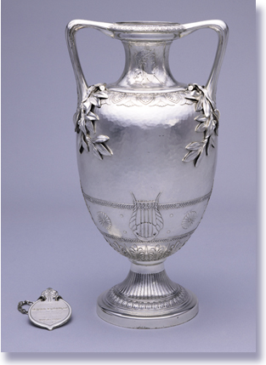
Discovering the Story: A City and Its Culture
Convert the Music

Tiffany & Co. (1853-) Vase and Dedication Medallion, 1878
Silver
Bequest of Reuben R. Springer 1884.483
A Math Lesson for Grades 4-8
based on Vase and Dedication Medallion by Tiffany & Co.
Discovering the Story: A City and Its Culture
Convert the Music
A Math Lesson for Grades 4-8
Based on Vase & Medallion, 1878 by Tiffany & Co.

Concept 2
Objectives 3
Teacher Preparation 3
Class Periods Required 3
Background Information 3
Video 3
Pre- Videoconference 3
Vocabulary 3
Guiding Questions 4
Materials 4
Procedure 4
Videoconference 6
Objectives 6
Concept 6
Schedule 6
Post- Videoconference 7
Class Periods Required 7
Procedure 7
Assessment Objectives 8
Academic Content Standards 8
National Standards: Mathematics 8
National Standards: Visual Art 9
National Standards: Music 9
Ohio Standards: Mathematics 9
Ohio Standards: Visual Art 9
Where’s The Note/Rest? What’s The Fraction? 11
Convert the Music 13
Concept
In this musical lesson on converting fractions to decimals and percents, teachers will review student understanding of fractions and introduce the method of converting fractions to decimals and percents. Students will explore and understand these concepts through close examination of music notes and musical notation. Students apply this knowledge to a series of mathematical problems using skills obtained in this lesson..

The teacher will facilitate students in hands-on applications and study of lessons main objectives through pre videoconferencing classroom activities, a videoconference visit with Cincinnati Art Museum staff, and post-videoconferencing lesson activities.

Objectives
- Students will review that fractions are the subdivision of a unit into equal parts.
- Students will understand that musical notes are like fractions in that they represent parts of a whole.
- Students will learn the method in which fractions can be converted into decimals and percents.
- Students will look at music notes as fractions and will apply this knowledge to a series of mathematical problems using skills obtained in this lesson.

Teacher Preparation

Class Periods Required

1 (30-50 min.) class period for Pre-Lesson Activities
1 50-min. class period for Videoconference
1 (30-50 min.) class period for introduction of Post-Lesson Activities
1-2 (30-50 min.) class periods for Art Enrichment Activity (optional)

Background Information
Refer to Background Information for more on Reuben Springer and the Museum’s Vase and Dedication Medallion and the company that created them. Background Information is on the website at http://www.discoveringthestory.org/goldenage/springer/background.asp and has been written for teachers to review before the lesson and then share with students.

Video
Share the Vase and Dedication Medallion video with your students prior to the videoconference. The video, which is on the Discovering the Story website at http://www.discoveringthestory.org/goldenage/springer/video.asp, is an interview with a Museum curator on Reuben Springer and the Vase and Dedication Medallion. This video is an excellent resource that will help to prepare students for the videoconference.

Video Duration – five minutes.

Pre- Videoconference
Vocabulary

Definitions can be found in the Glossary on the Discovering the Story website at http://www.discoveringthestory.org/goldenage/springer/glossary.asp
Decimal
Fraction
Measure (Music)
Musical Note
Whole Note
Half Note
Quarter Note
Eighth Note
Sixteenth Note
Percent
Rests
Whole Rest
Half Rest
Quarter Rest
Eighth Rest
Sixteenth Rest

Guiding Questions
- What is a fraction and how are they expressed?
- What is a decimal and how are they expressed?
- What is a percent and how are they expressed?
- What is music and how is it expressed?
- How are fractions and music notes the same? Different?

Materials
- Print reproductions of the Museum’s Vase and Dedication Medallion on the website at http://www.discoveringthestory.org/goldenage/springer/images/springer_full.jpg
- Music Note Flashcards which can be downloaded from the website at http://www.discoveringthestory.org/goldenage/springer/flashcards.pdf

Procedure
Teacher will:
- Share with students the visual reproduction of the Museum’s Vase and Dedication Medallion. Ask students to look at the pieces closely and describe what they see. Record all responses on the board. Share the Background Information on the Museum’s Vase and Dedication Medallion with students. Upon reviewing the history of this vase, ask students why they think the artist included a lyre (harp) on the front of the vase. (Because it was given to Springer at the opening of Music Hall and we play music on musical instruments like lyres. )
- Ask students, who among them plays a musical instrument? Ask those students to share with the class how they now what kind of music to play when they play their instrument. They should all say that they read notes. Ask them to explain what notes are? Ask them the names of the different notes (whole note, half note, quarter note, etc.) Ask if they realized that when they play different notes, except for the whole note, they are actually playing fractions.
- Share with students that musical notes are like fractions in that they represent parts of a whole and that today they are going to investigate fractions by looking at musical notes. Before moving on, students should have a firm understanding that fractions are the subdivision of a unit into equal parts and have the ability to identify the following fractions 1/16, 1/8, 1/4, and 1/2 and their relation to the whole.
- Share the following basics on notes and rests with students:
- A Note determines the length of time that the note is played by the musician.
- A Rest determines the length of time the musician rests or doesn’t play.
- Notes and rests are placed on a musical device known as a measure.
- Each measure consists of a combination of notes/rests that equal one whole note. Much like a series of fractions equals one whole. For this lesson, all measures will be four beats long, meaning a whole note will be worth four beats.
- At this time, introduce the different kinds of notes and rests using the Music Note Flashcards. Students should be able to identify both sixteenth, eighth, quarter, half and whole notes and rests as well as the fractions of the whole each represents.
- Musical Note to Teachers: It is important that students understand that while a whole note is held four beats, it still is considered for our purposes in looking at fractions as the whole.
- Other note/fraction rules:
- a whole note/rest is held for four beats – or a whole number as it relates to fractions
- a half note/rest is held for 2 beats - or as a fraction, half –1/2 of a whole note
- a quarter note/rest is held for one beat - or as a fraction, quarter – 1/4 of a whole note
- an eighth note/rest is held for half of one beat - or as a fraction, an eighth - 1/8 of a whole note
- a sixteenth note/rest is held a quarter of one beat - or as a fraction, a sixteenth – 1/16 of a whole note
- Musical Note to Teachers: It is important that students understand that while a whole note is held four beats, it still is considered for our purposes in looking at fractions as the whole.
- Other note/fraction rules:
- a whole note/rest is held for four beats – or a whole number as it relates to fractions
- a half note/rest is held for 2 beats - or as a fraction, half –1/2 of a whole note
- a quarter note/rest is held for one beat - or as a fraction, quarter – 1/4 of a whole note
- an eighth note/rest is held for half of one beat - or as a fraction, an eighth - 1/8 of a whole note
- a sixteenth note/rest is held a quarter of one beat - or as a fraction, a sixteenth – 1/16 of a whole note
Teacher Note: For those of you experienced in reading music, this lesson we will be using only 4/4 time.
- To emphasize the way different notes sound as how they represent the parts of a whole, teacher may ask a student who plays a musical instrument to perform each type of note for the class. Another option would be to play a clapping game in which students clap each type of note. For Example:
- A whole note can be represented by one clap with three bounces (the clap is on the first count, the three bounces represent 3 remaining counts of the note.
- A half note can be represented by one clap and one bounce (the clap is on the first count, the bounce is the second count)
- A quarter note can be represented by 4 equal claps (one clap for each count)
- A eighth note can be represented by 2 short/quick claps (one clap each for half of one count)
- A sixteenth note can be represented by 4 short/quick claps (one clap for each quart of one count)
- To show how notes can be combined to equal a whole note, the teacher may choose to split the team into groups with each group clapping a different kind note simultaneously while counting out loud. Students should begin and end at the at the same time.
- Once students fully comprehend the relationship between fractions and musical notes, share with them that they are now going to meet someone from the Cincinnati Art Museum and they are going to learn more about the Vase and Dedication Medallion.

Videoconference

Objectives
- Students will interact with the Cincinnati Art Museum staff through a sixty-minute videoconference. Information on the videoconference is on the Discovering the Story website at http://www.discoveringthestory.org/videoconference/
- Students will learn about Cincinnati history from 1850 to 1900.
- Students will use Museum objects to reinforce activities completed in preparation for this videoconference.

Concept
A videoconference conducted by the Cincinnati Art Museum staff extends student learning through emphasis on the viewing and discussion of art objects. During this videoconference with the Museum, students will explore Cincinnati art history and the methods and practices of many of the artists working in the city.

Schedule
- 5 minutes Introduction to CAM staff (This is also buffer time in case of connection complications)

- 10 minutes Brief discussion of student pre-videoconferencing activities.

- 10 minutes Museum staff will lead an interactive discussion with students on the history of Cincinnati from 1850-1900

- 20 minutes Museum staff will lead students in an in-depth investigation of selected Museum objects.

Objects Include
- Bedstead by Benn Pitman, Adelaide Nourse Pitman, and Elizabeth Nourse. http://www.discoveringthestory.org/goldenage/images/bedstead_full.jpg
- Reception Dress by Selina Cadwallader. This image can be found at
http://www.discoveringthestory.org/goldenage/images/dress_full.jpg
- Aladdin Vase by Maria Longworth Nichols Storer, which is available at
http://www.discoveringthestory.org/goldenage/images/aladdin_full.jpg
  - Ali Baba Vase by M. Louise McLaughlin, which is available at
http://www.discoveringthestory.org/goldenage/images/alibaba_full.jpg
- Vase and Dedication Medallion by Tiffany & Co. This image is on the Website at
http://www.discoveringthestory.org/goldenage/images/springer_full.jpg

- 10 minutes Questions and student sharing of art projects.

- 5 minutes Closing (This is also buffer time in case of connection complications)

Post - Videoconference

Materials
- Map of Cincinnati or map of your own city, which is on the website at http://www.discoveringthestory.org/goldenage/springer/images/cincinnatimap.jpg
- List of communities in Greater Cincinnati, which can be found on the website at http://www.discoveringthestory.org/goldenage/springer/communities.pdf
- Print reproduction of the Museum’s Vase and Dedication Medallion (downloaded from http://www.discoveringthestory.org/goldenage/springer/images/springer_full.jpg)
- Music Note Flashcards http://www.discoveringthestory.org/goldenage/springer/flashcards.pdf
- Where’s The Note/Rest? What’s The Fraction? Worksheet (at the end of this document)
- Convert the Music Worksheet (at the end of this document)

Procedure
Teacher will:
- Review with students what they learned during the video conference with the Museum, students should be more aware of the history of not only the Vase and Dedication Medallion, but also the city of Cincinnati.
- Review with students the Music Note Flashcards.
- Review with students that notes/fractions are combined in music to form measures and each measure must create a whole, just like a combination of fractions create a whole. For example: Teacher should write examples on the board .
+ + =
1 half rest + 2 quarter notes = 1 whole note or ½ + ¼ + ¼ = 1

Another example:

+ + =
1 Half Note + 1 Quarter Note + 1 Quarter rest = 1 whole note or ½ + ¼ + ¼ =1

- Continue creating note/rest/fraction combinations with students for practice. Stress to students that all note combinations must equal one whole note. Have students complete the Where’s the Note? What’s the Fraction Worksheet for extra practice.
- Now that students fully understand how notes and rests are broken up into measures, tell students that they are now going to practice their conversion skills and convert several lines of music into first fractions, then decimals and finally into percents. Tell students, that even though decimals and percents are not used in musical notation, they are going to use notes/fractions to practice their conversion skills.
- At this time, teacher should introduce/review converting fractions into decimals and percents. Students should have full understanding of these skills before completing the Convert the Music Worksheet.
- Once students finish this worksheet, encourage them to go back to the Where’s the Note? What’s the Fraction Worksheet and convert each note and fraction to decimals and percents.

Lesson Extension:
- As an extension, students can create several measures of their own music each of which contain notes or rests that combine to make a whole. Students must include the fraction, decimal and percent breakdown for each measure of music they create.

Assessment Objectives
- Student reviews that fractions are the subdivision of a unit into equal parts.
- Student understands that musical notes are like fractions in that they represent parts of a whole.
- Student understands and applies the method for converting fractions into decimals and percents.
- Student completes the Where’s the Note? What’s the Fraction Worksheet and the Convert the Music Worksheet.

Academic Content Standards

National Standards: Mathematics
Standard 2: Understands and applies basic and advanced properties of the concepts of numbers

Grades 3-5
Benchmark 2: Understands equivalent forms of basic percents, fractions, and decimals (e.g., 1/2 is equivalent to 50% is equivalent to .5) and when one form of a number might be more useful than another.

Grades 6-8
Benchmark 1: Understands the relationships among equivalent number representations (e.g., whole numbers, positive and negative integers, fractions, ratios, decimals, percents, scientific notation, exponentials) and the advantages and disadvantages of each type of representation

National Standards: Visual Art
Standard 4: Understands the visual arts in relation to history and cultures

Grades 5-8
Benchmark 2: Understands the historical and cultural contexts of a variety of art objects
Benchmark 3: Understands how factors of time and place (e.g., climate, resources, ideas, technology) influence visual, spatial, or temporal characteristics that give meaning or function to a work of art

National Standards: Music

Standard 5: Reads and notates music

Grades 3-5
Benchmark 1: Reads whole, half, dotted half, quarter, and eighth notes and rests in 2/4, 3/4, and 4/4 meter signatures

Grades 6-8
Benchmark 1: Reads sixteenth and dotted notes and rests in 6/8, 3/8, and alla breve (2/2) meter signatures

Ohio Standards: Mathematics
Number, Number Sense and Operations Standard: Students demonstrate number sense, including an understanding number systems and operations and how they relate to one another. Students compute fluently and make reasonable estimates using paper and pencil, technology-supported and mental methods.

Grades 3-4
Benchmark C: Represent commonly used fractions and mixed numbers using words and physical models.

Grades 5-7
Benchmark B: Compare, order and convert among fractions, decimals and percents.

Ohio Standards: Visual Art
Historical, Cultural and Social Contexts: Students understand the impact of visual art on the history, culture and society from which it emanates. They understand the cultural, social and political forces that, in turn, shape visual art communication and expression. Students identify the significant contributions of visual artists to cultural heritage. They analyze the historical, cultural, social and political contexts that influence the function and role of visual art in the lives of people.

Grades 5-8
Benchmark D: Researches culturally or historically significant works of art and discusses their roles in society, history, culture or politics.

Where’s The Note/Rest? What’s The Fraction?

Sample:
Notes: + + + =

Fractions: 1/8 + 1/8 + 1/4 + 1/2 = 1

1. + + =

1/2 + ___ + ___ = ___

2. ___ + + = ___

1/4 + ___ + ___ = 1

3. 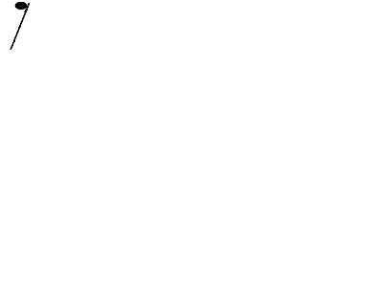 + ___ + ___ + ___ + ___ =

1/8 + 1/8 + 1/8 + 1/8 + 1/2 = ___

4. ___ + ___ +  + + = ___

1/2 + ___ + ___ + ___ + ___ = 1

5. ___ + + ___ + ___ =

___ + ___ + 1/4 + ___ =

6. + + ___ = ___

___ + ___ + ___ = 1

7. ___ + ___ + ___ + ___ + + ___ = ___

1/8 + ___ + ___ + ___ + ___ + ___ = 1

8. + + + ___ = ___

___ + ___ + ___ + ___ = 1

Create Your Own Measures – Remember They Must Equal One or

9.

10.

Convert the Music

Sample:
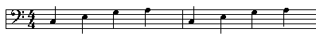
Fractions: ¼ ¼ ¼ ¼ ¼ ¼ ¼ ¼

Decimals: .25 .25 .25 .25 .25 .25 .25 .25

Percents: 25% 25% 25% 25% 25% 25% 25% 25%

Fill-In Missing Fractions, Decimals and Percents for Each Line
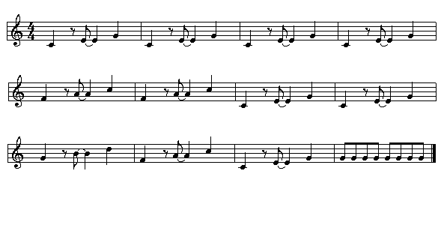
1.

Fractions: ____________________________________________________________________________________

Decimals: ____________________________________________________________________________________

Percents: ____________________________________________________________________________________

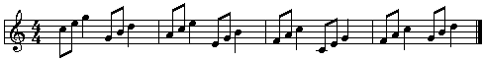
2.

Fractions: ____________________________________________________________________________________

Decimals: ____________________________________________________________________________________

Percents: ____________________________________________________________________________________

3.

Fractions: ____________________________________________________________________________________

Decimals: ____________________________________________________________________________________

Percents: ______________________________________________________________________________________•
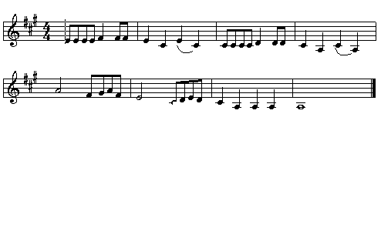

4.

Fractions: ____________________________________________________________________________________

Decimals: ____________________________________________________________________________________

Percents: ____________________________________________________________________________________

• Music Samples: Music Teacher Resource Site - http://www.mtrs.co.uk/

