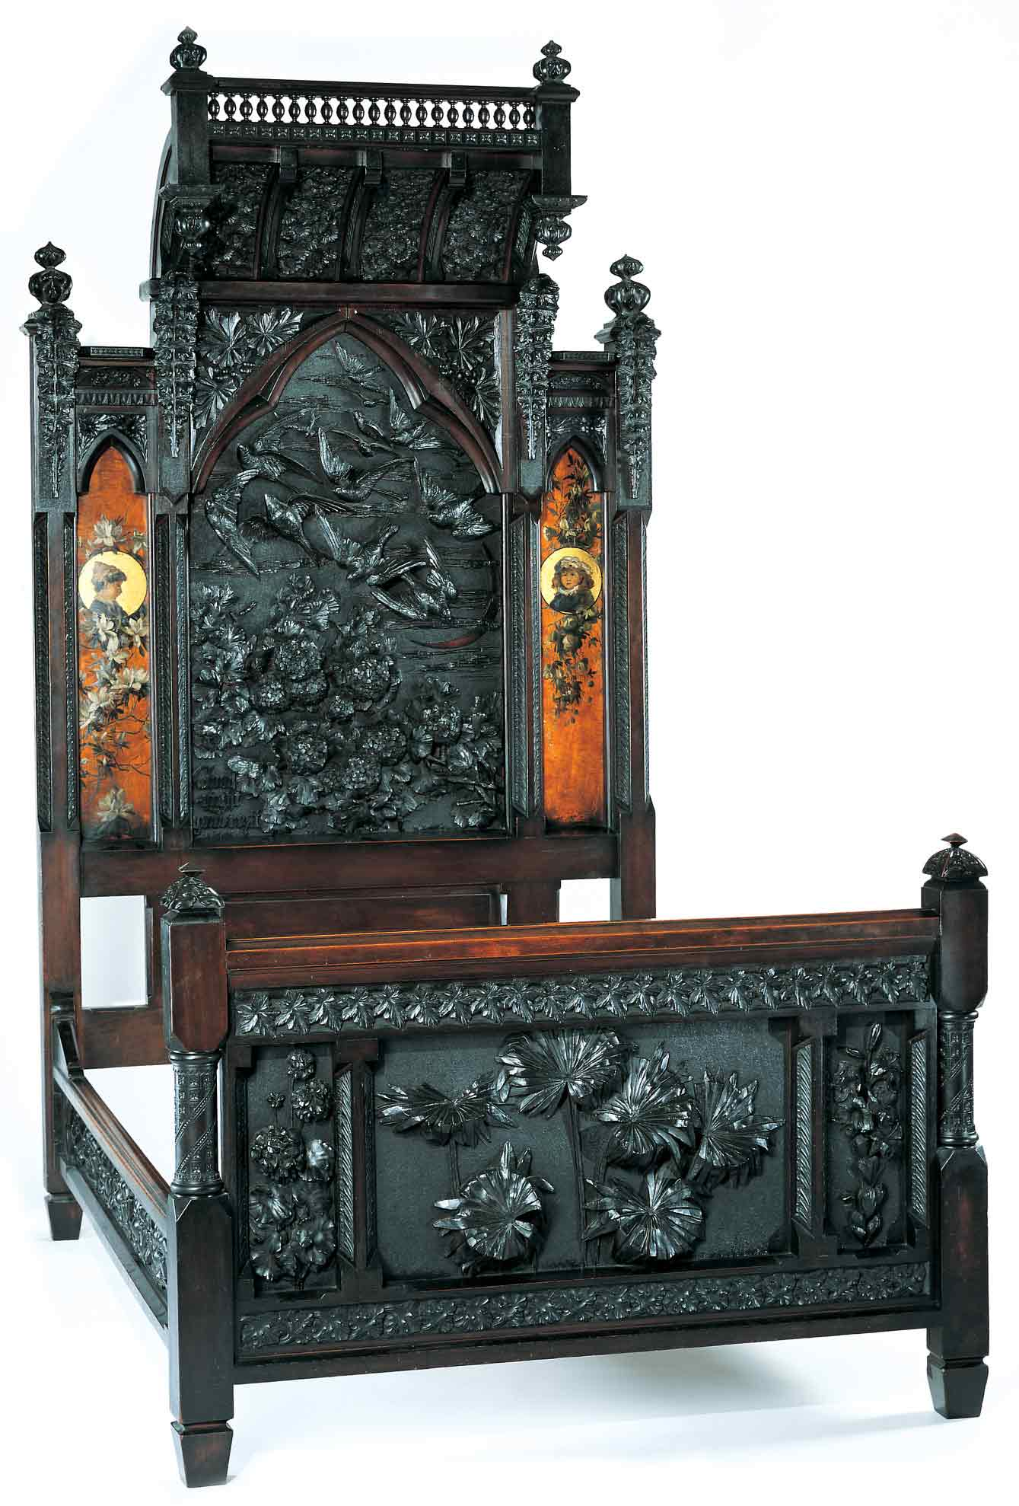
Discovering the Story:
A City and Its Culture

The Art in Living Things

A Science Lesson for Grades K-3

Based on Bedstead
by Benn Pitman, Adelaide Nourse Pitman and Elizabeth Nourse

Benn Pitman (1822-1910), designer; Adelaide Nourse Pitman (1859-93), carver; and Elizabeth Nourse (1859-1938), painter
Bedstead, c. 1882-83
Gift of Mary Jane Hamilton in memory of her mother Mary Luella Hamilton, made possible through Rita S. Hudepohl, Guardian, 1994.61

Concept

The Museum’s Bedstead incorporates high-relief carvings of various plants and trees indigenous to the natural habitats of the Cincinnati area. The teacher will facilitate students in a discussion on the basic needs of living things. Teachers will also lead in the identification of these plants through pre-videoconferencing lesson activities, a videoconference visit with Cincinnati Art Museum staff, and post-videoconferencing lesson activities. Students, through inquiry, observation, and hands-on investigation, will develop a greater understanding of plants, trees, and their habitats, as well as an appreciation of living things found both in nature and in art.
Objectives
- Students will appreciate the art and design of Benn Pitman and the Nourse sisters.
- Students will understand and describe the basic needs and functions of living things.
- Students will gather and communicate information from careful observations and simple investigation in the format of scientific journals—Leaflet.

Teacher Preparation
Class Periods Required
1 to 2 (30-50 min.) periods for Pre-Lesson Activities
1 (50-min.) class period for Videoconference
1 week for Post-Lesson Activities
1 to 2 (30-50 min.) periods for Art Enrichment Activity (optional)

Background Information
Background Information, which contains additional details on the Bedstead and the artists who created it, has been written for teachers to review before the lesson and then share with students and can be found at http://www.discoveringthestory.org/goldenage/bed/background.asp.

Video
Share the wood-carving video with your students prior to the videoconference. The video, which is online at http://www.discoveringthestory.org/goldenage/bed/video.asp, depicts wood carver Fred Wilbur as he carves in the style of works in the Museum. He speaks at length on the Bedstead. This video is an excellent resource that will help to prepare students for the videoconference. Video Duration – 5 minutes.

Pre- Videoconference Lesson Activities
Vocabulary

Definitions can be found in the Glossary on the website at http://www.discoveringthestory.org/goldenage/bed/glossary.asp.
Flower
Fruit
Leaf
Living
Nonliving
Root
Seed
Stem
Vein

Guiding Questions
- What is a living thing?
- What do living things need to grow and survive?
- What are the parts of a plant?
- Why are plants important?

Materials
Print and/or download the following digital images. You should have a detail image from the Bedstead and a real-life image of each of the following plants:
Azalea
Bedstead Image:
http://www.discoveringthestory.org/goldenage/images/bed_azalea_full.jpg
Real-life Image:
http://www.discoveringthestory.org/goldenage/images/real_azalea_full.jpg
Balloon Vine
Bedstead Image:
http://www.discoveringthestory.org/goldenage/images/bed_balloon_full.jpg
Real-life Image:
http://www.discoveringthestory.org/goldenage/images/real_balloon_full.jpg
Daisy
Bedstead Image: http://www.discoveringthestory.org/goldenage/images/bed_daisy_full.jpg
Real-life Image: http://www.discoveringthestory.org/goldenage/images/real_daisy_full.jpg
Daylily
Bedstead Image: http://www.discoveringthestory.org/goldenage/images/bed_daylily_full.jpg
Real-life Image: http://www.discoveringthestory.org/goldenage/images/real_daylily_full.jpg
Geranium
Bedstead Image: http://www.discoveringthestory.org/goldenage/images/bed_geranium_full.jpg
Real-life Image: http://www.discoveringthestory.org/goldenage/images/real_geranium_full.jpg
Hydrangea
Bedstead Image: http://www.discoveringthestory.org/goldenage/images/bed_hydrangea_full.jpg
Real-life Image: http://www.discoveringthestory.org/goldenage/images/real_hydrangea_full.jpg
Palmetto (Palmeris)
Bedstead Image: http://www.discoveringthestory.org/goldenage/images/bed_palmetto_full.jpg
Real-life Image: http://www.discoveringthestory.org/goldenage/images/real_palmetto_full.jpg
Wild Parsnip
Bedstead Image: http://www.discoveringthestory.org/goldenage/images/bed_wild_parsnip_full.jpg
Real-life Image: http://www.discoveringthestory.org/goldenage/images/real_wild_parsnip_full.jpg
Poppy
Bedstead Image: http://www.discoveringthestory.org/goldenage/images/bed_poppy_full.jpg
Real-life Image: http://www.discoveringthestory.org/goldenage/images/real_poppy_full.jpg
Wild Rose
Bedstead Image: http://www.discoveringthestory.org/goldenage/images/bed_wild_rose_full.jpg
Real-life Image: http://www.discoveringthestory.org/goldenage/images/real_wild_rose_full.jpg
Visual of the Pitman Bedstead

Procedure
Teacher will:
- Use the guiding questions to lead a discussion on living things.
- Ask students to make a list of living things. You may do this as a class activity with each child contributing something to the discussion.
- Review with students what a living thing, like a plant, needs to survive – water, oxygen, sunlight, and food. Ask them if they need these things to survive.
- Tell them that they are going to look at a picture of something that was made from a living thing (tree) and that is covered with pictures of living things (plants and animals).
- Introduce students to a visual of the Bedstead.
- Share with students the detail images of the plant representations from the Bedstead.
- Share with students the images of the real-life plants represented on the Bedstead.
- With students, match the plant representations from the Bedstead with its real-life image.
- Ask students whether the plants on the Bedstead look like the actual images of the plants. Why would they look different? Do they think the people who designed and carved the Bedstead looked at actual plants for inspiration? Tell them that they will get a chance to ask that question when they meet the people from the Cincinnati Art Museum during the videoconference.

Videoconference
Objectives
- Students will interact with the Cincinnati Art Museum staff through a sixty-minute videoconference. Information on the videoconference can be found on the Discovering the Story website at http://www.discoveringthestory.org/videoconference/.
- Students will learn about Cincinnati history from 1850 to 1900.
- Students will use Museum objects to reinforce activities completed in preparation for this videoconference.

Concept
A videoconference conducted by the Cincinnati Art Museum staff extends student learning through emphasis on the viewing and discussion of art objects. During this videoconference with the Museum, students will explore Cincinnati art history and the methods and practices of many of the artists working in the city.

Schedule
- 5 minutes Introduction to CAM staff (This is also buffer time in case of connection complications)

- 10 minutes Brief discussion of student pre-videoconferencing activities.

- 10 minutes Museum staff will lead an interactive discussion with students on the history of Cincinnati from 1850-1900

- 20 minutes Museum staff will lead students in an in-depth investigation of selected Museum objects.

Objects Include
- Bedstead by Benn Pitman, Adelaide Nourse Pitman, and Elizabeth Nourse. http://www.discoveringthestory.org/goldenage/images/bedstead_full.jpg
- Reception Dress by Selina Cadwallader. This image can be found at
http://www.discoveringthestory.org/goldenage/images/dress_full.jpg
- Aladdin Vase by Maria Longworth Nichols Storer, which is available at
http://www.discoveringthestory.org/goldenage/images/aladdin_full.jpg
  - Ali Baba Vase by M. Louise McLaughlin, which is available at
http://www.discoveringthestory.org/goldenage/images/alibaba_full.jpg
- Vase and Dedication Medallion by Tiffany & Co. This image is on the Website at
http://www.discoveringthestory.org/goldenage/images/springer_full.jpg

- 10 minutes Questions and student sharing of art projects.

- 5 minutes Closing (This is also buffer time in case of connection complications)

Post- Videoconference Lesson Activities
Materials
- Drawing and writing tools
- Magnifying lenses
- Handout A, which can be found at the end of the lesson
- Clipboards (one per student)

Procedure
Teacher will:
- View the wood-carving video with class. Inform students that in order to make realistic representations of living things, Mr. Wilbur is required to closely observe those things in nature.
- Explain to students the purpose of a class nature walk to conduct personal observations and identifications of living things just like Mr. Wilbur.
- Guide students on a nature walk in a nearby park or nature preserve. Ask students to observe the living things in their chosen surroundings.
- Have students record their observations on Handout A, which can be found at the end of the lesson.
- Encourage the discovery of plants and trees as found on the Bedstead. (Have accompanying visuals of the Bedstead flora on hand for comparison.)
- Encourage the discovery of similarities and differences between the living plants and trees in the surrounding habitat.
- Instruct students to identify parts of plants and trees in the habitat, and evidence of their basic needs being met.
- Support student observations with the activities of drawing and labeling, photography, bark and leaf rubbings, and close-up viewing through magnifying lenses.
- Discuss with students, upon return from their walk, their observations and findings of the local habitat, plants, and trees within that habitat.

Materials for Leaflet – Scientific Journals for Note-Taking
- Blank paper for writing and drawing for booklet pages
- Construction paper for booklet covers
- Drawing and writing tool

- Hole puncher
- Scissors

Procedure for Leaflet – Scientific Journals for Note-Taking
Teacher will:
- Have students cut out blank paper and construction paper into leaf shapes, or have booklet pages pre-cut for student use.
- Join together the pages using staples or a hole punch and metal rings.
- Students will transfer field notes into Leaflet. Information to record or gather regarding a specific plant, tree, and habitat will include:
- Name of student
- Date of activity
- Location of observation
- Observation of living things (various or specific plants and trees). May include drawings, photos, rubbings, samples, etc.
- Observation of parts of a plant or tree
- Observations of things needed for a plant’s basic needs—water source, light source, soil, food, and air.
- Students will now write a brief narrative on the benefits of field observation for the study of plants and trees.

Assessment Objectives
- Student Leaflet journal entries should be accurate.
- Students should be able to define a habitat and environmental influences.
- Students should be able to define a native plant.
- Students should be able to write a brief narrative on the benefits of field observation for the study of plants and trees.

Academic Content Standards
National Standards: Science

Life Science
Standard 5: Understands the structure and function of cells and organisms.
Grades K-2
Benchmark 1: Knows the basic needs of plants and animals (e.g., air, water, nutrients, light or food, shelter).

Standard 6: Understands relationships among organisms and their physical environments.
Grades K-2
Benchmark 1: Knows that plants and animals need certain resources for energy and growth.

Nature of Science
Standard 12: Understands the nature of scientific inquiry.
Grades K-2
Benchmark 1: Knows that learning can come from careful observations and simple experimentation.

National Standards: Visual Arts
Standard 4: Understands the visual arts in relation to history and cultures.
Grades K-4
Benchmark 1: Knows that the visual arts have both a history and a specific relationship to various cultures.
Benchmark 2: Identifies specific works of art as belonging to particular cultures, times, and places.
Benchmark 3: Knows how history, culture, and the visual arts can influence each other.

Ohio Standards: Science
Life Sciences: Students demonstrate an understanding of how living systems function and how they interact with the physical environment. This includes an understanding of the cycling of matter and flow of energy in living systems. An understanding of the characteristics, structure, and function of cells, organisms, and living systems will be developed. Students will also develop a deeper understanding of the principles of heredity, biological evolution, and the diversity and interdependence of life. Students demonstrate an understanding of different historical perspectives, scientific approaches, and emerging scientific issues associated with the life sciences.

Grades K-2
Benchmark A: Discovers that there are living things, non-living things, and pretend things, and describes the basic needs of living things (organisms).
Benchmark B: Explains how organisms function and interact with their physical environments.

Scientific Inquiry: Students develop scientific habits of mind as they use the processes of scientific inquiry to ask valid questions and to gather and analyze information. They understand how to develop hypotheses and make predictions. They are able to reflect on scientific practices as they develop plans of action to create and evaluate a variety of conclusions. Students are also able to demonstrate the ability to communicate their findings to others.
Grades K-2
Benchmark C: Gathers and communicates information from careful observations and simple investigation through a variety of methods.

Ohio Standards: Visual Arts
Historical, Cultural, and Social Contexts: Students understand the impact of visual art on history, culture, and society from which it emanates. They understand the cultural, social, and political forces that, in turn, shape visual art communication and expression. Students identify the significant contributions of visual artists to cultural heritage. They analyze the historical, cultural, social, and political contexts that influence the function and role of visual art in the lives of people.

Grades K-4

Benchmark A: Recognizes and describes visual art forms and artworks from various times and places.

Analyzing and Responding: Students identify and discriminate themes, media, subject matter, and formal technical and expressive aspects in works of art. They understand and use the vocabulary of art criticism to describe visual features, analyze relationships, and interpret meanings in works of art. Students make judgments about the quality of works of art using the appropriate criteria.

Grades K-4
Benchmark A: Identifies and describes the visual features and characteristic in works of art.

Handout A

Field Observation

Name

This is the living thing I see

I see evidence of…
Sunlight | Water |  | Air |  | Soil
Rubbing |  | Seed Sample |  | Leaf Sample

