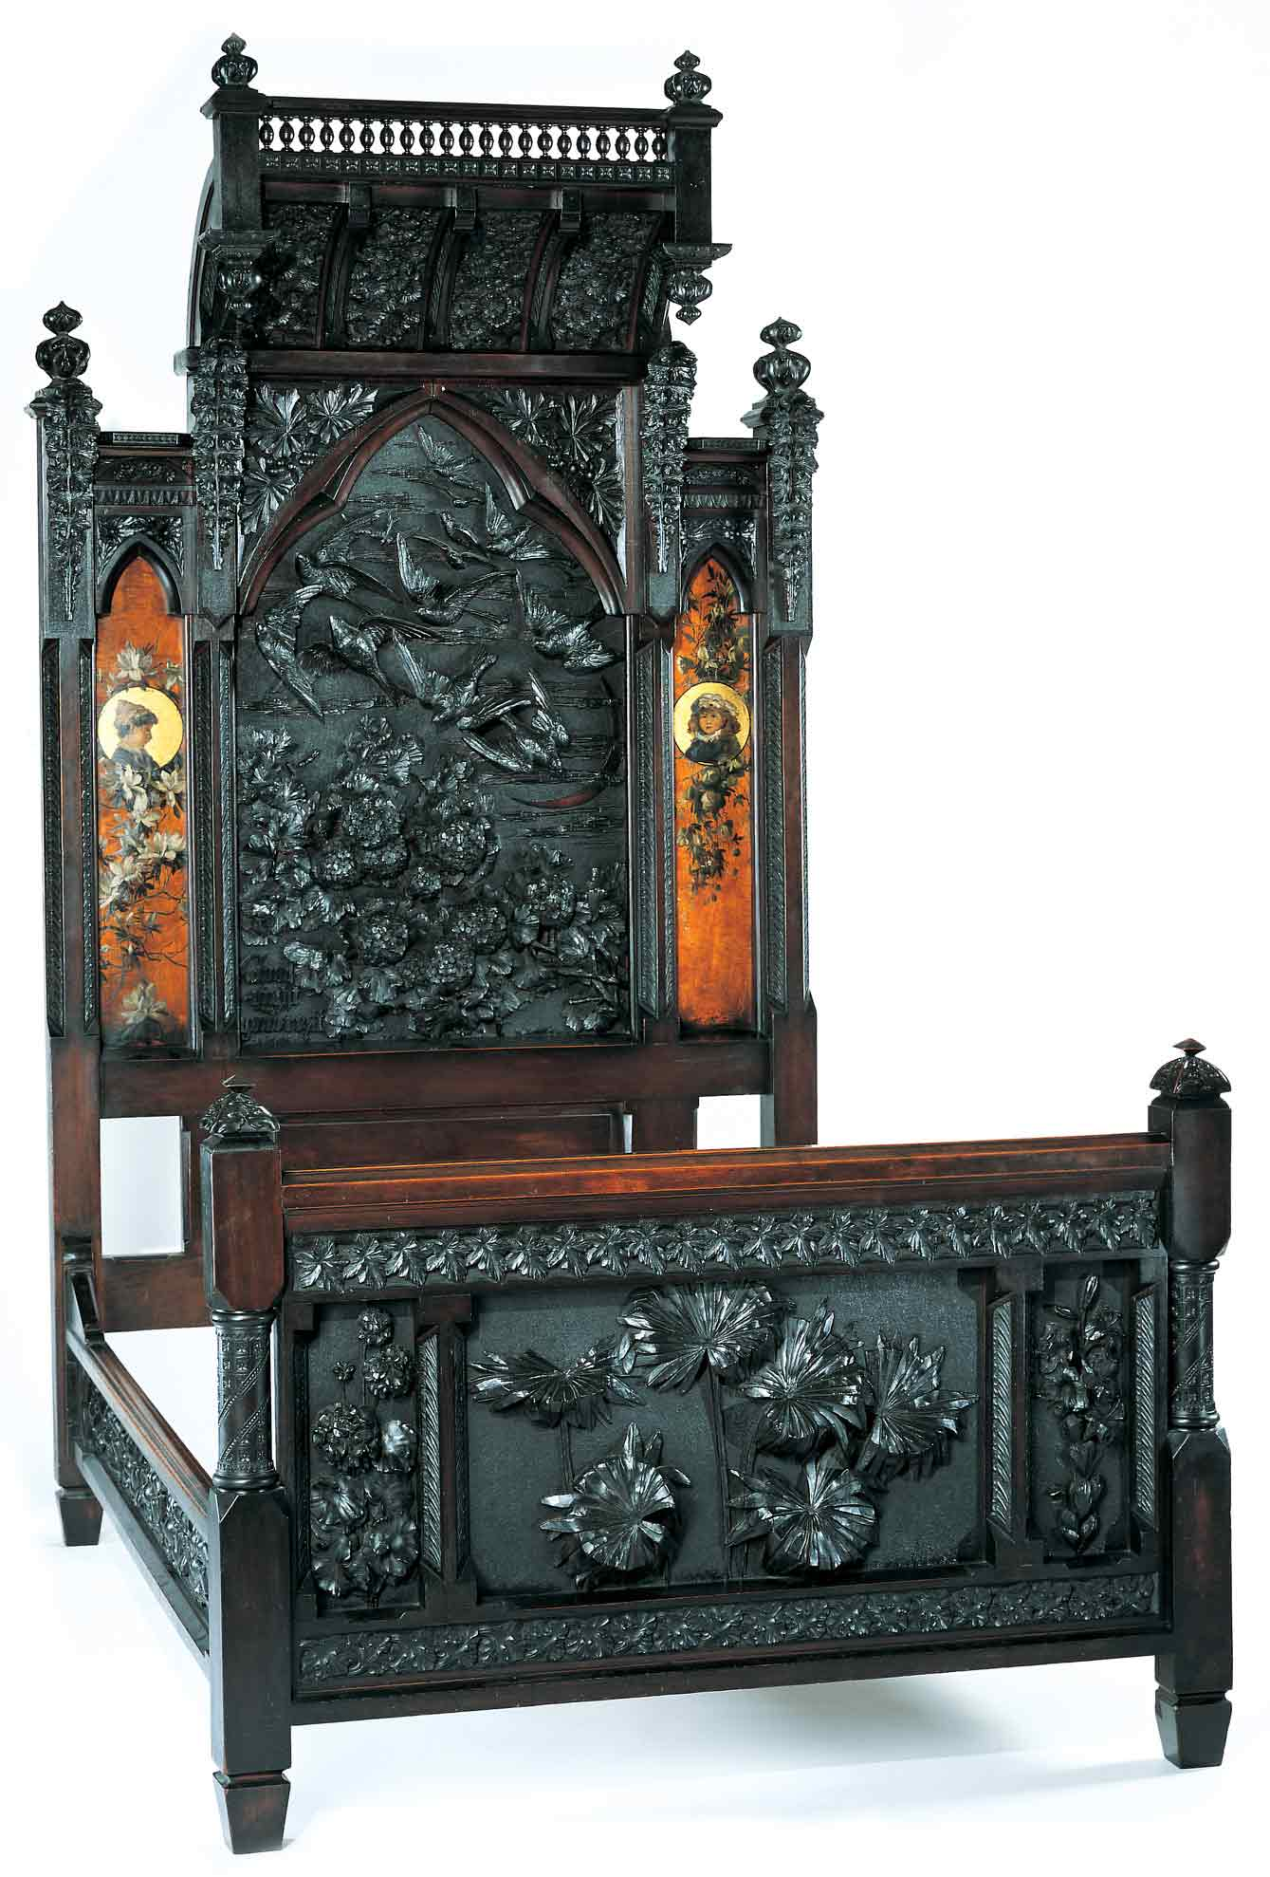
Discovering the Story:
A City and Its Culture

Who is an Artist?

A Social Studies Lesson for
Grades K-3

Based on Bedstead
by Benn Pitman, Adelaide Nourse Pitman and Elizabeth Nourse

Benn Pitman (1822-1910), designer; Adelaide Nourse Pitman (1859-93), carver; and Elizabeth Nourse (1859-1938), painter
Bedstead, c. 1882-83
Gift of Mary Jane Hamilton in memory of her mother Mary Luella Hamilton, made possible through Rita S. Hudepohl, Guardian, 1994.61

Concept
Introduction to the role of Cincinnati as a leader in the global art community and the development of art education will lead to student recognition of the historical significance of the Pitman Bedstead, designed in the late 1800s, and carved and painted by Cincinnati women artists.

The teacher will facilitate students in hands-on applications and study through pre-videoconferencing classroom activities, a videoconference visit with Cincinnati Art Museum staff, and post-videoconferencing lesson activities. Emphasis is on student insight into the daily life of individuals in the early nineteenth century and the role of women artists in society.

Objectives

Students will conduct inquiry into the daily life of late 1800 Cincinnati communities using primary and secondary resources.

Students will explore how the study of art objects benefits learning in other content domains (e.g., the study of local history).

Students will explore the lives and contributions of women artists in late1800 society, including, Adelaide Nourse Pitman, and Elizabeth Nourse and the “art-carved” Pitman Bedstead.
- Students will present the significant discoveries in the format of pictorial reports and a time line.

Teacher Preparation
Class Periods Required
1 to 2 (30-50 min.) periods for Pre-Lesson Activities
1 (50-min.) class period for Videoconference
1 week for Post-Lesson Activities
1 to 2 (30-50 min.) periods for Art Enrichment Activity (optional) which can be found on the website at http://www.discoveringthestory.org/goldenage/bed/arts.asp

Background Information
Background Information, which contains additional details on the Bedstead and the artists who created it, has been written for teachers to review before the lesson and then share with students. Background information on the Benn Pitman bedstead can be found on the website at http://www.discoveringthestory.org/goldenage/bed/background.asp.

Video

Share the wood-carving video with your students prior to the videoconference. The video, which is on the website at http://www.discoveringthestory.org/goldenage/bed/video.asp, depicts wood carver Fred Wilbur as he carves in the style of works in the Museum. He speaks at length on the Bedstead. This video is an excellent resource that will help to prepare students for the videoconference.

Video Duration – 5 minutes.

Pre- Videoconference Lesson Activities
Vocabulary

Definitions can be found in the Glossary on the Discovering the Story website at http://www.discoveringthestory.org/goldenage/bed/glossary.asp.
Autobiography
Biography
Primary source
Secondary source
Time line
Wood carving

Guiding Questions
- What is art?
- Who and what is an artist?
- How does an artist contribute to a community?
- What was a day in one’s life like in the late 1880s?
- What is a time line?
- What is the function of a time line?
- Why is the understanding of time lines important to the study of history? Art history?

Materials
- Artifacts and other objects representative of life in the late 1800s, perhaps objects found in your attic, at garage sales, flea markets or borrowed from a friend. If objects are unattainable, look for images of objects in your history text or on the Internet.
- Photos from primary and secondary sources depicting scenes of life in the late 1800s, particularly those of Cincinnati
- Print and nonprint resources for student inquiry
- Downloaded and printed images , which can be found on the Discovering the Story website at http://www.discoveringthestory.org/videoconference/index.asp
- Artist profiles of Adelaide Nourse Pitman, Elizabeth Nourse, and Benn Pitman, can be downloaded and printed from the Discovering the Story website at http://www.discoveringthestory.org/goldenage/bed/background.asp.

Procedure
Teacher will:
- Print or download the following images. Each set of images has a picture of an artist and an example of one of their artworks.
Frank Duveneck
http://www.discoveringthestory.org/goldenage/images/Duveneck_full.jpg
Whistling Boy
http://www.discoveringthestory.org/goldenage/images/Whistling_Boy_full.jpg
Maria Longworth Nichols Storer
http://www.discoveringthestory.org/goldenage/images/Storer_full.jpg
Basket http://www.discoveringthestory.org/goldenage/images/Basket_full.jpg
Benn Pitman
http://www.discoveringthestory.org/goldenage/images/BennPitman_full.jpg
Plaque http://www.discoveringthestory.org/goldenage/images/Plaque_full.jpg
Mary Louise McLaughlin
http://www.discoveringthestory.org/goldenage/images/McLaughlin_full.jpg
Charger http://www.discoveringthestory.org/goldenage/images/Charger_full.jpg
Teacher key to images, linking each artist to his or her work, which can be found at
http://www.discoveringthestory.org/goldenage/bed/SS_K3_teacher_key.asp
- Share each image with students.
- Separately display an image of an artist and a representative artwork.
- Ask students to match the artwork to its artist.
- Engage students in a discussion as to why they made particular matches.
- Reveal which artist created which artwork.
- Emphasize to students that an artist can be anyone and may create a range of all kinds of art.
- Facilitate student discussion for the following questions.
- Who is an artist? (Emphasis on who creates art and why)
- What is an artist? (Emphasis on the role and function in a community and in society)
- Why is art important? (Emphasis on benefits to a community or society)
- What are some examples of artwork found in a community? (Emphasis of art objects found in a home, school, park, etc. of the late 1800s and today)
- Construct instructional stations around the room for student inquiry of objects representative of life in the 1800s (e.g., clothing, toys, household appliances, books, etc.).
- Instruct students to examine artifacts, objects, and photos to discover representative art from the late 1800s.
- Instruct students to record findings on an observation sheet available at each station.
- Engage students in a discussion on their findings.
- Ask students how artists were important in contributing to the making of these artifacts for community life.
- Introduce students to a picture of the Bedstead. Ask students whether they think the bedstead is art. Inform students that a woman artist (a twin sister) actually carved this bed out of one large tree trunk. The other twin sister painted the pictures on the bed.
- Introduce students to the artists Benn Pitman, Adelaide Nourse Pitman, and Elizabeth Nourse. Emphasize highlights of their lives and contributions to the Cincinnati community.
- Share with students in particular the artist profiles of Adelaide Nourse Pitman and Elizabeth Nourse. Because this information was written for teacher preparatory work, teacher may want to summarize this information for students and not read it aloud to the class.
- Facilitate student discussion on the fact that these women/sisters were considered artists and woodcarving and painting were their professions. Emphasize that both women contributed to their community by decorating furniture.
- View with students the Fred Wilbur video to illustrate the craft of woodcarving used by the Nourse sisters.
- Have students, individually or as a class, create a list of questions to ask of the CAM staff about the Nourse sisters and the Bedstead during a scheduled videoconference.
- Fax (513) 639-2998 or email these questions to the Cincinnati Art Museum: emily.holtrop@cincyart.org. If time allows, the videoconferencing instructor will answer student questions.

Videoconference
Objectives
- Students will interact with the Cincinnati Art Museum staff through a sixty-minute videoconference. Information on the videoconference can be found on the Discovering the Story website at http://www.discoveringthestory.org/videoconference/index.asp.
- Students will learn about Cincinnati history from 1850 to 1900.
- Students will use Museum objects to reinforce activities completed in preparation for this videoconference.

Concept
A videoconference conducted by the Cincinnati Art Museum staff extends student learning through emphasis on the viewing and discussion of art objects. During this videoconference with the Museum, students will explore Cincinnati art history and the methods and practices of many of the artists working in the city.

Schedule
- 5 minutes Introduction to CAM staff (This is also buffer time in case of connection complications)

- 10 minutes Brief discussion of student pre-videoconferencing activities.

- 10 minutes Museum staff will lead an interactive discussion with students on the history of Cincinnati from 1850-1900

- 20 minutes Museum staff will lead students in an in-depth investigation of selected Museum objects.

Objects Include
- Bedstead by Benn Pitman, Adelaide Nourse Pitman, and Elizabeth Nourse. http://www.discoveringthestory.org/goldenage/images/bedstead_full.jpg
- Reception Dress by Selina Cadwallader. This image can be found at
http://www.discoveringthestory.org/goldenage/images/dress_full.jpg
- Aladdin Vase by Maria Longworth Nichols Storer, which is available at
http://www.discoveringthestory.org/goldenage/images/aladdin_full.jpg
  - Ali Baba Vase by M. Louise McLaughlin, which is available at
http://www.discoveringthestory.org/goldenage/images/alibaba_full.jpg
- Vase and Dedication Medallion by Tiffany & Co. This image is on the Website at
http://www.discoveringthestory.org/goldenage/images/springer_full.jpg

- 10 minutes Questions and student sharing of art projects.

- 5 minutes Closing (This is also buffer time in case of connection complications)

Post- Videoconference Lesson Activities
Materials
- Crayons
- Internet access
- Library access
- Magazines
- Markers
- Paper
- Pencils

Procedure
Teacher will:
- Explain to students that while they were able to ask the Museum staff questions about the Nourse sisters and the Bedstead, for additional information, research is required using various resources--print, nonprint, primary, and secondary.
- Introduce concepts and working definitions, which can be found on the website in the glossary at http://www.discoveringthestory.org/goldenage/bed/glossary.asp, for informational resources and the terms primary and secondary. Accompany introductions with concrete examples.
- Explain to students that they are now going to conduct research on a female artist who was living and working at the same time as the Nourse sisters (see list below for suggestions) to learn of her contributions to a community.
Late nineteenth-early twentieth Century Women Artists
Mary Cassatt (1844-1926), American (Pittsburgh) -- Painter
Lilly Martin Spencer (1822-1902), American (Cincinnati) -- Painter
Edmonia Lewis (1845-1911), American (New York) -- Sculptor
Rosa Bonheur (1822-1899), French -- Painter
Camille Claudel (1864-1943), French -- Sculptor
Berthe Morisot (1841-1895), French -- Painter
Malvina Hoffman (1887-1966), American (New York) -- Sculptor
Georgia O’Keefe (1887-1986), American (Wisconsin) – Painter
Maria Longworth Nichols Storer (1849-1932), American (Cincinnati) -- Ceramics
Bessie Potter Vonnoh (1872-1955), American (St. Louis) – Sculptor
Mary Louise McLaughlin (1847-1939), American (Cincinnati) – Ceramics
Dixie Selden (1868-1935), American (Covington) – Painter
Bessie Hoover Wessel (1888-1973), American (Cincinnati) – Painter
Emma Bepler (1864-1947), American (Cincinnati) – Wood carver
Käthe Kollwitz (1867-1945) German – Sculptor

- Have students brainstorm what information will be collected, where the information will be found, and who will assist them with finding this information (e.g., art teacher, library media specialist, teacher, parent, community member, etc.).
- Have students conduct their research (very limited for the younger students) and present their findings in the form of a time line (see the following time line emphases). For younger ages, the class may choose one female artist and work on the research and time line together.
- Introduce definition, concept, elements, and structure of a time line with concrete examples.

Time Line Emphases
- Name of subject (female artist)
- Date and location of artist’s birth
- Two events for each of these three stages of the artist’s life?
- Names of three works of art by this artist and when were they made
- Date and location of artist’s death
Students will create their time lines using paper, pencils, crayons, and pictures from the Internet, magazines, or copied from books. Students may also draw an interpretive portrait of their selected female artist researched, and provide an accompanying written mini-narrative (age appropriate).

Assessment Objectives

- Students will understand the concepts, role, and function of art and artists in a community.
- Students will compile research and present information on the life of a female artist and her contribution to community life, locally and to United States and World History.
- Students will demonstrate an understanding of time lines through completion of classroom activities and tasks.

Academic Content Standards
National Standards: History

Grades K-4 History
Topic 1: Living and Working Together in Families and Communities, Now and Long Ago
Standard 2: Understands the history of a local community and how communities in North America varied long ago.
Benchmark 2: Understands the contributions and significance of historical figures of the community.

Topic 2: The History of Students' Own State or Region
Standard 3: Understands the people, events, problems, and ideas that were significant in creating the history of their state.

Grades 3-4
Benchmark 7: Knows the chronological order of major historical events that are part of the state’s history, their significance, the impact on people then and now, and their relationship to the history of the nation.

Historical Understanding Standard and Benchmarks
Standard 1: Understands and knows how to analyze chronological relationships and patterns.

Grades K-2
Benchmark 1: Knows how to identify the beginning, middle, and end of historical stories, myths, and narratives.

Benchmark 2: Knows how to develop picture time lines of their own lives or their families’ histories.

Benchmark 4: Understands calendar time in years, decades, and centuries.

Grades 3-5

Benchmark 2: Knows how to construct time lines in significant historical developments that mark, at evenly spaced intervals, the years, decades, and centuries.

Benchmark 3: Knows how to interpret data presented in time lines (e.g., identify the time at which events occurred; the sequence in which events developed; what else was occurring at the time).

National Standards: Visual Arts
Standard 4: Understands the visual arts in relation to history and cultures.
Grades K-4
Benchmark 1: Knows that the visual arts have both a history and a specific relationship to various cultures.
Benchmark 2: Identifies specific works of art as belonging to particular cultures, times, and places.
Benchmark 3: Knows how history, culture, and the visual arts can influence each other.

Ohio Standards: Social Studies
History Standard: Students use materials drawn from the diversity of human experience to analyze and interpret significant events, patterns, and themes in the history of Ohio, the United States, and the world.

Grades K-2
Benchmark B: Places events in correct order on a time line.
Benchmark C: Compares daily life in the past and present, demonstrating an understanding that while basic human needs remain the same, they are met in different ways in different times and places.
Benchmark D: Recognizes that the actions of individuals make a difference, and relates the stories of people from diverse backgrounds who have contributed to the heritage of the United States.

Grades 3-5
Benchmark A: Constructs time lines to demonstrate an understanding of units of time and chronological order.
Benchmark C: Explains how new developments led to the growth of the United States.

Social Studies Skills and Methods: Students collect, organize, evaluate, and synthesize information from multiple sources to draw logical conclusions. Students communicate this information using appropriate social studies terminology in oral, written, or multimedia form and apply what they have learned to societal issues in simulated or real-world settings.
Grades K-2
Benchmark A: Obtains information from oral, visual, print, and electronic sources.
Benchmark C: Communicates information orally, visually, or in writing.
Grades 3-5
Benchmark A: Obtains information from a variety of primary and secondary sources using the component parts of the source.
Benchmark B: Uses a variety of sources to organize information and draw inferences.
Benchmark C: Communicates social studies information using graphs or tables.
Benchmark D: Uses problem-solving skills to make decisions individually and in groups.

Ohio Standards: Visual Arts
Historical, Cultural, and Social Contexts: Students understand the impact of visual art on history, culture, and society from which it emanates. They understand the cultural, social, and political forces that, in turn, shape visual art communication and expression. Students identify the significant contributions of visual artists to cultural heritage. They analyze the historical, cultural, social, and political contexts that influence the function and role of visual art in the lives of people.

Grades K-4

Benchmark A: Recognizes and describes visual art forms and artworks from various times and places.

Analyzing and Responding: Students identify and discriminate themes, media, subject matter, and formal technical and expressive aspects in works of art. They understand and use the vocabulary of art criticism to describe visual features, analyze relationships, and interpret meanings in works of art. Students make judgments about the quality of works of art using the appropriate criteria.

Grades K-4
Benchmark A: Identifies and describes the visual features and characteristic in works of art.

