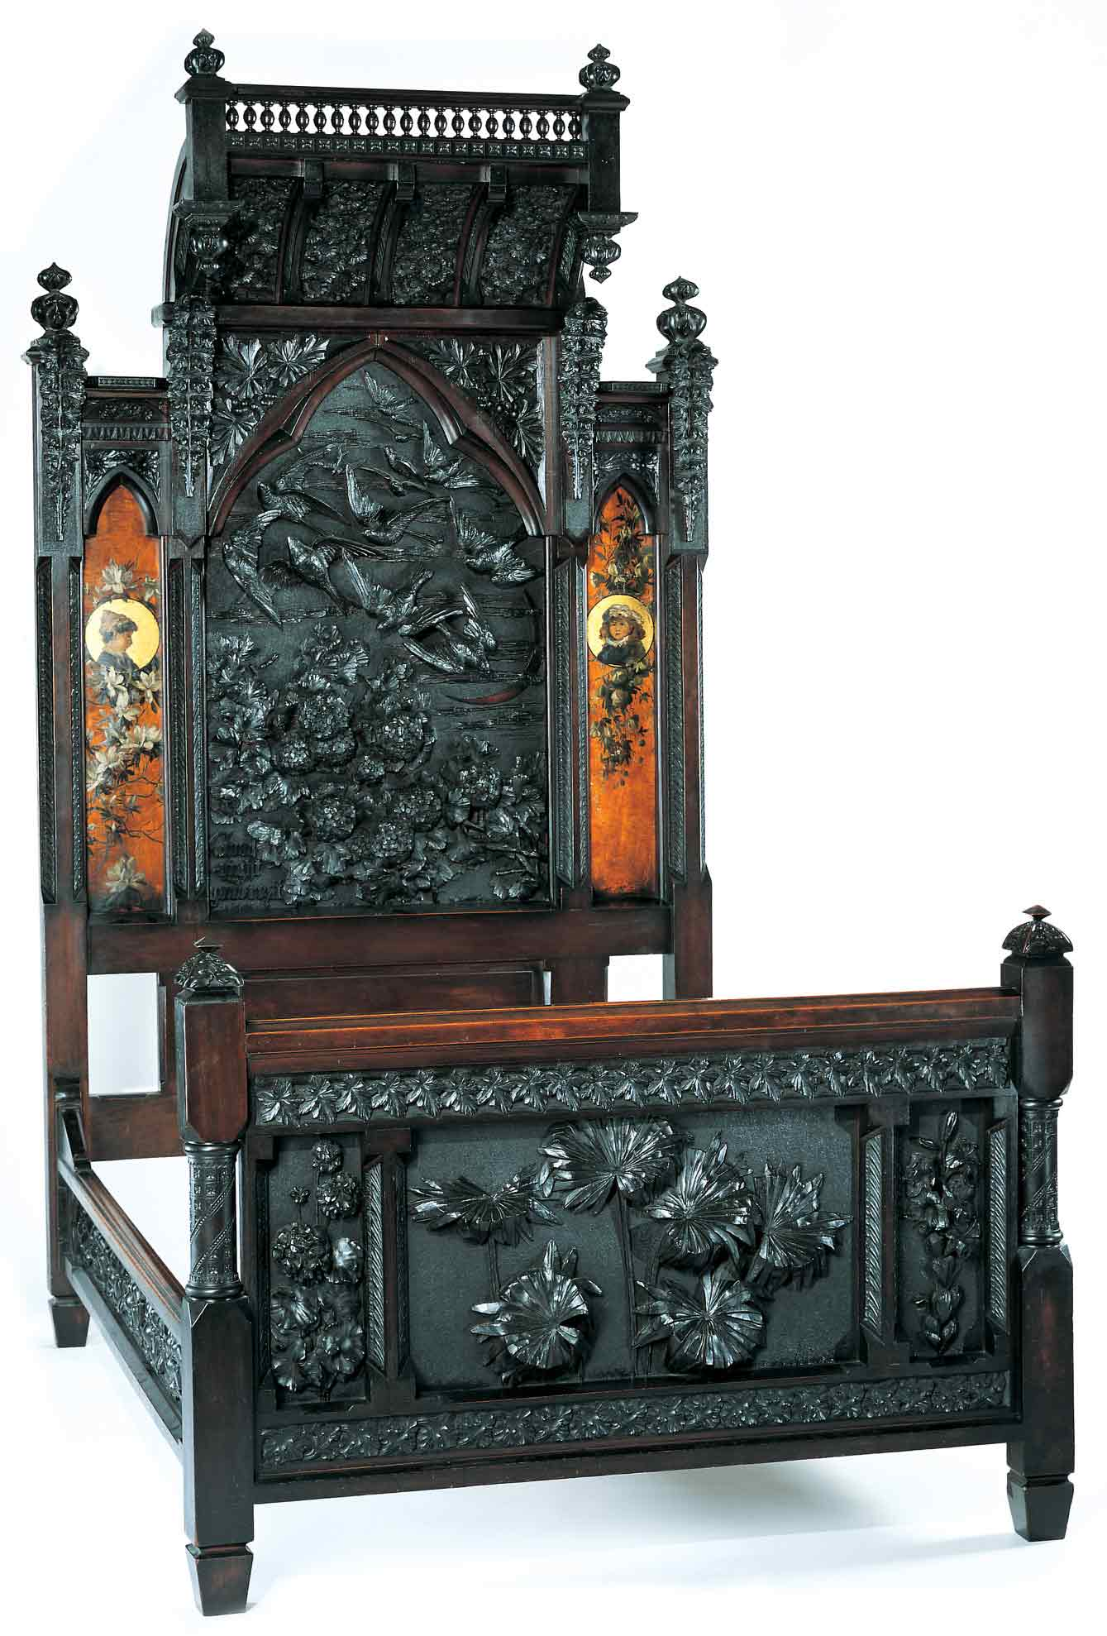
Discovering the Story
A City and Its Culture

Geometric Shapes in Everyday Objects

A Math Lesson for Grades K-3

Based on Bedstead
by Benn Pitman, Adelaide Nourse Pitman and Elizabeth Nourse

Benn Pitman (1822-1910), designer; Adelaide Nourse Pitman (1859-93), carver; and Elizabeth Nourse (1859-1938), painter
Bedstead, c. 1882-83
Gift of Mary Jane Hamilton in memory of her mother Mary Luella Hamilton, made possible through Rita S. Hudepohl, Guardian, 1994.61

CONCEPT

Looking at patterns carved on the Bedstead and shapes used in its construction, students will identify and describe basic plane figures (shapes) and line symmetry. The teacher will facilitate students in the study of basic plane figures and line symmetry found in everyday objects through pre-videoconferencing lesson activities, a videoconference visit with Cincinnati Art Museum staff, and post-videoconferencing lesson activities.
Objectives
- Students will describe and identify basic plane figures (shapes).
- Students will describe and identify line symmetry.
- Students will appreciate the art and design of Benn Pitman and the Nourse sisters.

Teacher Preparation

Class Periods Required
1 to 2 (30-50 min.) periods for Pre-Lesson Activities
1 (50-min.) class period for Videoconference
1 week for Post-Lesson Activities

Background Information
Background Information, which contains additional details on the Bedstead and the artists who created it, has been written for teachers to review before the lesson and then share with students. The background information can be found on the Discovering the Story website at http://www.discoveringthestory.org/goldenage/bed/background.asp.

Video
Share the wood-carving video with your students prior to the videoconference. The video, which is at http://www.discoveringthestory.org/goldenage/bed/video.asp, depicts wood carver Fred Wilbur as he carves in the style of works in the Museum. He speaks at length on the Bedstead. This video is an excellent resource that will help to prepare students for the videoconference.
Video Duration – 5 minutes.

Pre- Videoconference Lesson Activities

Vocabulary

Definitions can be found in the Glossary on the Discovering the Story website at http://www.discoveringthestory.org/goldenage/bed/glossary.asp

Circle
Line symmetry
Plane symmetry
Rectangle

Square
Triangle

Guiding Questions
- What shapes (plane figures) are incorporated into the Pitman headboard and footboard?
- What is line symmetry?
- What parts of the Bedstead show line symmetry and which do not?
Materials
- Chart paper
- Glue stick
- Crayons or markers
- Picture of the Bedstead, http://discoveringthestory.org/goldenage/images/bedstead_full.jpg
- Scissors
- Student copies of Bedstead

Procedure
Teacher will:
- Download the image of the Bedstead from the Discovering the Story website. Make a copy for each student. Have a brief discussion about the Bedstead and its creators, Benn Pitman and the Nourse sisters.
- Ask the students, as a group, to identify the shapes found on the image. Have students circle and label each shape. Have students describe each shape. Ask students why they think this bedstead has lots of shapes. Discuss how shapes are an element of both art and math and how they give structure and decoration to everyday objects.
- Use these shapes of different sizes to teach the concepts of line symmetry.
- Fold a shape, like a heart, a circle, or an isosceles triangle, in half to demonstrate line symmetry.
- Show students five items from your classroom that have line symmetry.
- Fold a shape like a hand, a shell, or a parallelogram in half to demonstrate something that does not have line symmetry.
- Show students five items from your classroom that do not have line symmetry.
- Have students cut out the shapes they identified on the Bedstead. They can then test them for line symmetry.
- Use another image of the Bedstead (one that has not been cut apart) to show that the entire bed has line symmetry.
- Use chart paper and write the words “line symmetry.” Make two columns, one for shapes that have line symmetry and one for shapes that do not have line symmetry. Place the examples from the classroom under the correct category. Make sure to state that an object with line symmetry has a centerline and has a mirror image (folds in half).
- Have students, for homework, work with their families to identify examples of shapes and line symmetry in their lives. Students will draw pictures or make a list of everyday objects they identify. These can be shared during the videoconference.

Videoconference

Objectives
- Students will interact with the Cincinnati Art Museum staff through a sixty-minute videoconference. Information for the videoconference is on the Discovering the Story website at
- Students will learn about Cincinnati history from 1850 to 1900.
- Students will use Museum objects to reinforce activities completed in preparation for this videoconference.

Concept
A videoconference conducted by the Cincinnati Art Museum staff extends student learning through emphasis on the viewing and discussion of art objects. During this videoconference with the Museum, students will explore Cincinnati art history and the methods and practices of many of the artists working in the city.

Schedule
- 5 minutes Introduction to CAM staff (This is also buffer time in case of connection complications)

- 10 minutes Brief discussion of student pre-videoconferencing activities.

- 10 minutes Museum staff will lead an interactive discussion with students on the history of Cincinnati from 1850-1900

- 20 minutes Museum staff will lead students in an in-depth investigation of selected Museum objects.

Objects Include
- Bedstead by Benn Pitman, Adelaide Nourse Pitman, and Elizabeth Nourse. http://www.discoveringthestory.org/goldenage/images/bedstead_full.jpg
- Reception Dress by Selina Cadwallader. This image can be found at
http://www.discoveringthestory.org/goldenage/images/dress_full.jpg
- Aladdin Vase by Maria Longworth Nichols Storer, which is available at
http://www.discoveringthestory.org/goldenage/images/aladdin_full.jpg
  - Ali Baba Vase by M. Louise McLaughlin, which is available at
http://www.discoveringthestory.org/goldenage/images/alibaba_full.jpg
- Vase and Dedication Medallion by Tiffany & Co. This image is on the Website at
http://www.discoveringthestory.org/goldenage/images/springer_full.jpg

- 10 minutes Questions and student sharing of art projects.

- 5 minutes Closing (This is also buffer time in case of connection complications)

Post- Videoconference Lesson Activities
Materials
- Paper (legal size, 8-1/2” x 14”) -- 10 sheets per child
- Pencils, crayons, or markers
- Stapler
- Old magazines

Procedure
Teacher will:
- Review with students the information provided in the videoconference and open a discussion on the shapes and symmetry found in art objects in the videoconference.
- Have each student create a geometry book using ten sheets of legal-size paper folded in half and stapled. Books will reinforce what they have learned about plane figures and line symmetry.
- Have students find, for their books, ten objects that have line symmetry (fold in half) and ten objects that do not have line symmetry (do not fold in half). If the objects are plane figures, they should be identified.
- Have students label any shapes they can identify. Pictures can be drawn or found in magazines, books or other media.
- Encourage students to look at their friends' books and make note of the best shapes for line symmetry.
- Use student work to show examples of plane figures and line symmetry.

Assessment Objectives

- Students can identify line symmetry accurately.
- Students create a geometry book where each of ten pages shows line symmetry and identifies shapes.
- Students understand the names and attributes of the different shapes.

Academic Content Standards
National Standards: Mathematics
Standard 5: Understands and applies basic and advanced properties of the concepts of geometry.

Grades K-2
Benchmark 1: Understands basic properties of (e.g., number of sides, corners, square corners) and similarities and differences between simple geometric shapes.
Grades 3-5
Benchmark 2: Understands basic properties of figures (e.g., two- or three-dimensionality, symmetry, number of faces, type of angle).

National Standards: Visual Arts
Standard 4: Understands the visual arts in relation to history and cultures.
Grades K-4
Benchmark 1: Knows that the visual arts have both a history and a specific relationship to various cultures.
Benchmark 2: Identifies specific works of art as belonging to particular cultures, times, and places.
Benchmark 3: Knows how history, culture, and the visual arts can influence each other.

Ohio Standards: Mathematics

Geometry and Spatial Sense Standard: Students identify, classify, compare, and analyze characteristics, properties, and relationships of one-, two-, and three-dimensional geometric figures and objects. Students use spatial reasoning, properties of geometric objects, and transformations to analyze mathematical situations and solve problems.

Grades K-2
Benchmark A: Describes and creates plane figures: circle, rectangle, square, triangle, hexagon, trapezoid, parallelogram, and rhombus, and identifies them in the environment.
Benchmark G: Identifies and draws figures with line symmetry.

Ohio Standards: Visual Arts
Historical, Cultural, and Social Contexts: Students understand the impact of visual art on history, culture, and society from which it emanates. They understand the cultural, social, and political forces that, in turn, shape visual art communication and expression. Students identify the significant contributions of visual artists to cultural heritage. They analyze the historical, cultural, social, and political contexts that influence the function and role of visual art in the lives of people.

Grades K-4

Benchmark A: Recognizes and describes visual art forms and artworks from various times and places.

Analyzing and Responding: Students identify and discriminate themes, media, subject matter, and formal technical and expressive aspects in works of art. They understand and use the vocabulary of art criticism to describe visual features, analyze relationships, and interpret meanings in works of art. Students make judgments about the quality of works of art using the appropriate criteria.

Grades K-4
Benchmark A: Identifies and describes the visual features and characteristic in works of art.

