Benn Pitman (1822-1910), designer; Adelaide Nourse Pitman (1859-93), carver; and Elizabeth Nourse (1859-1938), painter
Bedstead, c. 1882-83
Gift of Mary Jane Hamilton in memory of her mother Mary Luella Hamilton, made possible through Rita S. Hudepohl, Guardian, 1994.61

Discovering the Story:
A City and Its Culture

Good Night, Good Rest

A Language Arts Lesson for Grades K-3

Based on Bedstead
by Benn Pitman, Adelaide Nourse Pitman and Elizabeth Nourse

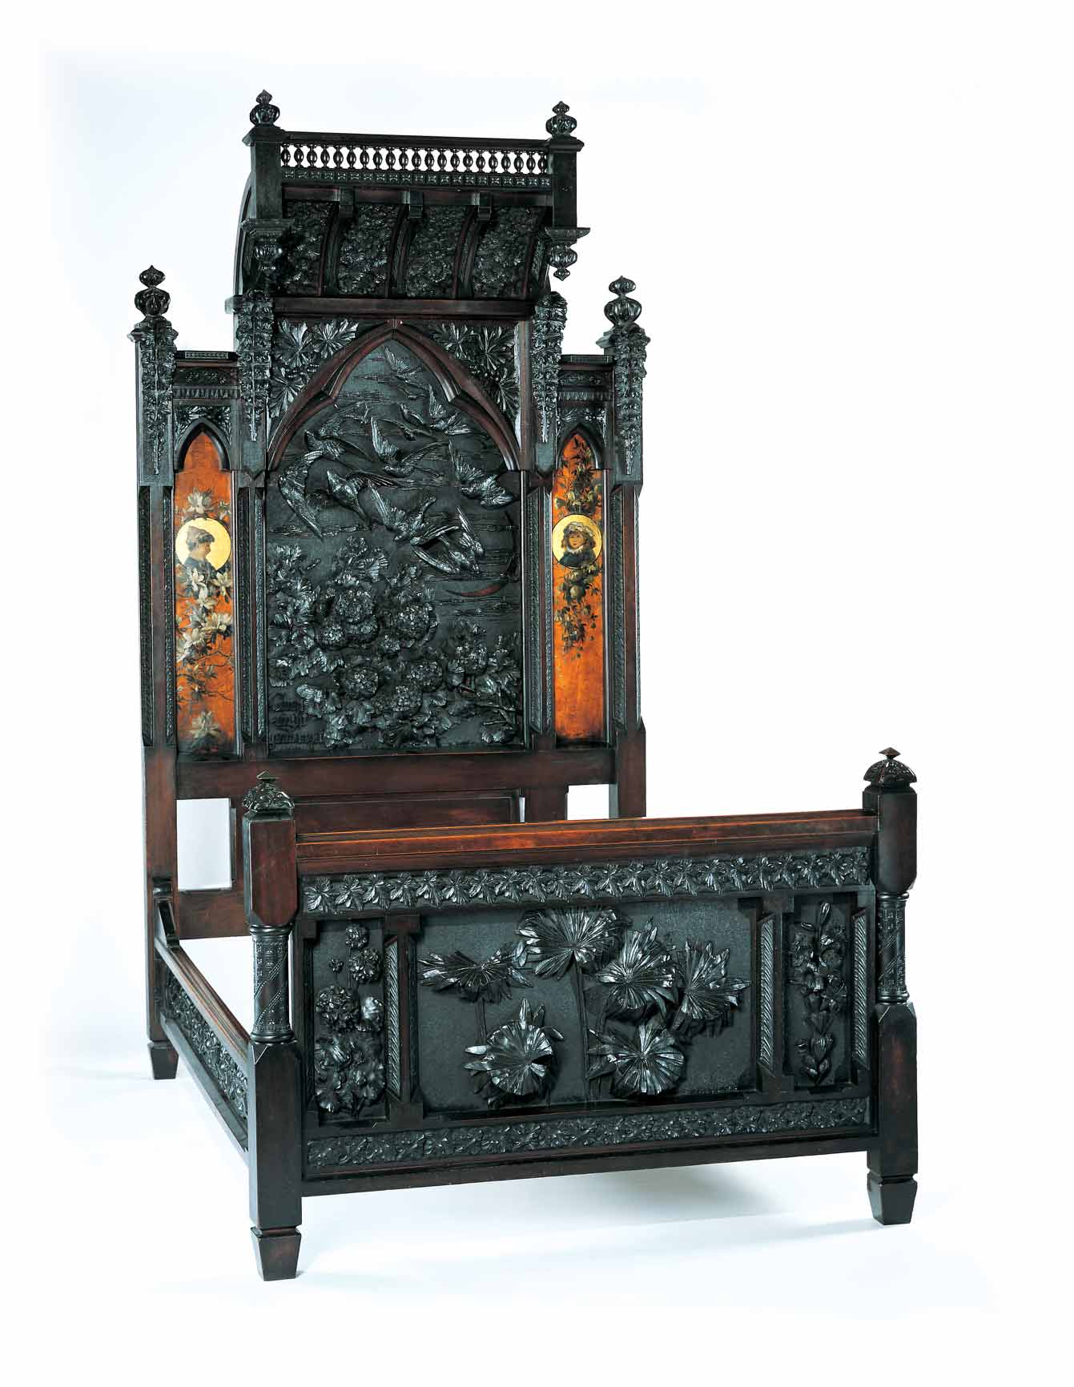

Concept

The object of focus, the Bedstead, designed and carved in the late 1880s, is representative of furniture-making by Cincinnati women artists. The bed incorporates intricate carvings of flora and fauna, and day and night imagery. The teacher will facilitate students in their understanding of their sleeping place, and in the creation of their own bed design through pre-videoconferencing lesson activities, a videoconference visit with the Cincinnati Art Museum, and post-videoconferencing lesson activities. Students, through this lesson, will reinforce skills in observation, comparison and contrast, and writing conventions.

Objectives
- Students will understand that various types of writing require different language, formatting, and special vocabulary. Students will compose writings that convey a clear message and include well-chosen details. They will deliberately choose vocabulary to enhance text and structure their writing according to audience and purpose.
- Students will be able to use descriptive language to refer to their own beds as compared to the Pitman Bedstead in written format.
- Students will identify and describe the visual features and characteristics in the Bedstead. Students will appreciate the art and design of Benn Pitman and the Nourse sisters.

Teacher Preparation
Class Periods Required
1 to 2 (30-50 min.) periods for Pre-Lesson Activities
1 (50-min.) class period for Videoconference
1 to 2 (30-50 min.) periods for Post-Lesson Activities
1 to 2 (30-50 min.) periods for Art Enrichment Activity (optional)

Background Information
Background Information, which contains additional details on the Bedstead and the artists who created it, has been written for teachers to review before the lesson and then share with students. The background information can be found on the Discovering the Story website at http://www.discoveringthestory.org/goldenage/bed/background.asp.

Video
Share the wood-carving video with your students prior to the videoconference. The, which can be found at http://www.discoveringthestory.org/goldenage/bed/video.asp, video depicts wood carver Fred Wilbur as he carves in the style of works in the Museum. He speaks at length on the Bedstead. This video is an excellent resource that will help to prepare students for the videoconference. Video Duration – 5 minutes.

Pre- Videoconference Lesson Activities

Vocabulary

Definitions can be found in the Glossary on the Discovering the Story website at http://www.discoveringthestory.org/goldenage/bed/glossary.asp.

Compare
Contrast

Description

Bedstead

Carving

Imagery

Guiding Questions
- What is imagery?
- How are objects similar?
- How are objects different?

Materials
- Image of The Pittman Bedstead which is on the website at http://discoveringthestory.org/goldenage/images/bedstead_full.jpg

Procedure
Teacher will:
- Introduce students to a visual of the Bedstead, and share the following facts for discussion.
- Benn Pitman designed the Bedstead.
- Adelaide Nourse (Benn’s wife) carved the Bedstead’s wooden images.
- Elizabeth Nourse (Adelaide’s sister) painted the pictures found on the Bedstead.
- Ask students to look closely and identify what they see on the Bedstead. List observations on the board/chart paper.
- Use Background Information provided by the Museum to add to the list generated by the students. Lead student discussion to address how images on the Bedstead impart information about Cincinnati in its late years of the 1800s (e.g., the native flora and fauna) and about the people who valued it.
- Ask students to compare/contrast the Bedstead to their sleeping places. This can be done in a large group or individually depending on grade/ability levels. (Note: care must be taken, as some children may not have their own beds.)
- Show wood-carving video. Discuss with the students what they learned.
- Based on observation of the Bedstead image, information from the Artist Profile sheet, and the students’ comparisons and contrasts of their sleeping places, develop a list of questions for the videoconference.

Videoconference
Objectives
- Students will interact with the Cincinnati Art Museum staff through a sixty-minute videoconference. Information on the videoconference is on the Discovering the Story website at http://www.discoveringthestory.org/videoconference/.
- Students will learn about Cincinnati history from 1850 to 1900.
- Students will use Museum objects to reinforce activities completed in preparation for this videoconference.

Concept
A videoconference conducted by the Cincinnati Art Museum staff extends student learning through emphasis on the viewing and discussion of art objects. During this videoconference with the Museum, students will explore Cincinnati art history and the methods and practices of many of the artists working in the city.

Schedule
- 5 minutes Introduction to CAM staff (This is also buffer time in case of connection complications)

- 10 minutes Brief discussion of student pre-videoconferencing activities.

- 10 minutes Museum staff will lead an interactive discussion with students on the history of Cincinnati from 1850-1900

- 20 minutes Museum staff will lead students in an in-depth investigation of selected Museum objects.

Objects Include
- Bedstead by Benn Pitman, Adelaide Nourse Pitman, and Elizabeth Nourse. http://www.discoveringthestory.org/goldenage/images/bedstead_full.jpg
- Reception Dress by Selina Cadwallader. This image can be found at
http://www.discoveringthestory.org/goldenage/images/dress_full.jpg
- Aladdin Vase by Maria Longworth Nichols Storer, which is available at
http://www.discoveringthestory.org/goldenage/images/aladdin_full.jpg
  - Ali Baba Vase by M. Louise McLaughlin, which is available at
http://www.discoveringthestory.org/goldenage/images/alibaba_full.jpg
- Vase and Dedication Medallion by Tiffany & Co. This image is on the Website at
http://www.discoveringthestory.org/goldenage/images/springer_full.jpg

- 10 minutes Questions and student sharing of art projects.

- 5 minutes Closing (This is also buffer time in case of connection complications)

Post- Videoconference Lesson Activities
Materials
- Drawing paper
- Crayons
- Colored pencils

Procedure
Teacher will:
- Ask students to look again at the Bedstead image and answer the following questions:
- Who made the Bedstead?
- What materials is it made of?
- When was it made?
- Where was it made?
- Why was it made?
- How does the Bedstead tell about the Cincinnati area?
- Ask the students to draw a picture of a bed they would like to sleep in, and have them name their beds.
- Have the students write their answers to the above questions in reference to their own bed creations depending on grade/ability levels.
- Have students compare and contrast their newly created beds to the Bedstead.
- Carry out the art enrichment activity. Students make models of the Bedstead.

Assessment Objectives
- Students are able to compare and contrast the Bedstead to their sleeping places.
- Students are able to meet criteria for written composition and visual illustration.

Academic Content Standards
National Standards: Language Arts - Reading
Standard 7: Uses reading skills and strategies to understand and interpret a variety of informational texts.

Grades K-2
Benchmark 1: Uses reading skills and strategies to understand a variety of informational texts (e.g., written directions, signs, captions, warning labels, informational books).

National Standards: Language Arts - Writing
Standard 1: Uses the general skills and strategies of the writing process.

Grades K-2
Benchmark 6: Uses writing and other methods (e.g., drawing pictures, using letters or phonetically spelled words, telling, dictating, making lists) to describe familiar persons, places, objects, or experiences.
Standard 2: Uses the stylistic and rhetorical aspects of writing.

Grades K-2
Benchmark 1: Uses descriptive words to convey basic ideas.
Standard 3: Uses grammatical and mechanical conventions in written compositions.

Grades K-2
Benchmark 1: Uses conventions of print in writing.
Benchmark 2: Uses complete sentences in written compositions.
Benchmark 3: Uses declarative and interrogative sentences in written compositions.
Benchmark 4: Uses nouns in written compositions.
Benchmark 5: Uses verbs in written compositions.
Benchmark 7: Uses adverbs in written compositions.
Benchmark 8: Uses conventions of spelling in written compositions.
Benchmark 9: Uses conventions of capitalization in written compositions.
Benchmark 10: Uses conventions of punctuation in written compositions.

National Standards: Visual Arts
Standard 4: Understands the visual arts in relation to history and cultures.
Grades K-4
Benchmark 1: Knows that the visual arts have both a history and a specific relationship to various cultures.
Benchmark 2: Identifies specific works of art as belonging to particular cultures, times, and places.
Benchmark 3: Knows how history, culture, and the visual arts can influence each other.

Ohio Standards: Language Arts

Reading Applications: Informational, Technical, and Persuasive Text: Students gain information from reading for purposes of learning about a subject, doing a job, making decisions, and accomplishing a task. Students need to apply the reading process to various types of informational texts, including essays, magazines, newspapers, textbooks, instruction manuals, consumer and workplace documents, reference materials, multimedia, and electronic resources. They learn to attend to text features, such as titles, subtitles, and visual aids, to make predictions and build text knowledge. They learn to read diagrams, charts, graphs, maps, and displays in text as sources of additional information. Students use their knowledge of text structure to organize content information, analyze it, and draw inferences from it. Strategic readers learn to recognize arguments, bias, stereotyping, and propaganda in informational text sources.

Grades K-3
Benchmark A: Uses text features and structures to organize content, draw conclusions, and build text knowledge.
Benchmark D: Uses visual aids as sources to gain additional information from text.

Writing Process: Students’ writing develops when they regularly engage in the major phases of the writing process. The writing process includes the phases of prewriting, drafting, revising, and editing and publishing. They learn to plan their writing for different purposes and audiences. They learn to apply their writing skills in increasingly sophisticated ways to create and produce compositions that reflect effective word and grammatical choices. Students develop revision strategies to improve the content, organization, and language of their writing. Students also develop editing skills to improve writing conventions.
Grades K-2
Benchmark A: Generates ideas for written compositions.
Benchmark B: Develops audience and purpose for self-selected and assigned writing tasks.

Writing Applications: Students need to understand that various types of writing require different language, formatting, and vocabulary. Writing serves many purposes across the curriculum and takes various forms. Beginning writers learn about the various purposes of writing; they attempt and use a small range of familiar forms (e.g., letters). Developing writers are able to select text forms to suit purpose and audience. They can explain why some text forms are more suited to a purpose than others and begin to use content-specific vocabulary to achieve their communication goals. Proficient writers control effectively the language and structural features of a large repertoire of text forms. They deliberately choose vocabulary to enhance text and structure their writing according to audience and purpose.

Grades K-2

Benchmark A: Composes writings that convey a clear message and include well-chosen details.

Writing Conventions: Students learn to master writing conventions through exposure to good models and opportunities for practice. Writing conventions include spelling, punctuation, grammar, and other conventions associated with forms of written text. They learn the purpose of punctuation: to clarify sentence meaning and help readers know how writing might sound aloud. They develop and extend their understanding of the spelling system, using a range of strategies for spelling words correctly and using newly learned vocabulary in their writing. They grow more skillful at using the grammatical structures of English to effectively communicate ideas in writing and to express themselves.

Grades K-2
Benchmark A: Prints legibly using appropriate spacing.
Benchmark B: Spells grade-appropriate words correctly.
Benchmark C: Uses conventions of punctuation and capitalization in written work.
Benchmark D: Uses grammatical structures in written work.

Ohio Standards: Visual Arts

Historical, Cultural, and Social Contexts: Students understand the impact of visual art on history, culture, and society from which it emanates. They understand the cultural, social, and political forces that, in turn, shape visual art communication and expression. Students identify the significant contributions of visual artists to cultural heritage. They analyze the historical, cultural, social, and political contexts that influence the function and role of visual art in the lives of people.

Grades K-4

Benchmark A: Recognizes and describes visual art forms and artworks from various times and places.

Analyzing and Responding: Students identify and discriminate themes, media, subject matter, and formal technical and expressive aspects in works of art. They understand and use the vocabulary of art criticism to describe visual features, analyze relationships, and interpret meanings in works of art. Students make judgments about the quality of works of art using the appropriate criteria.

Grades K-4

Benchmark A: Identifies and describes the visual features and characteristic in works of art.

