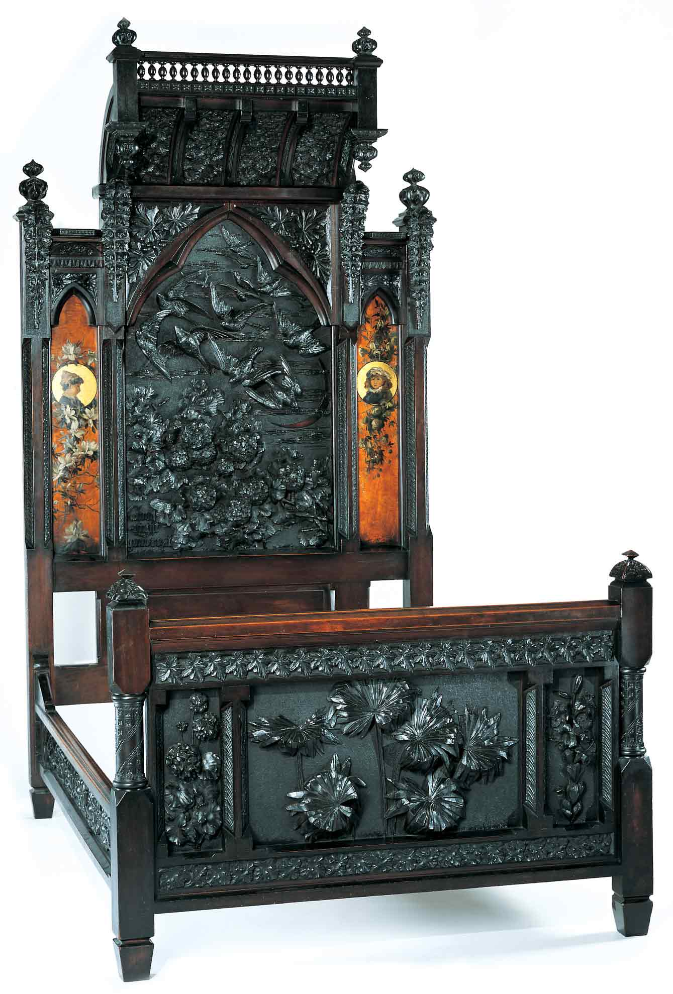
Discovering the Story:
A City and Its Culture

The Aesthetic Movement and the Pitman Bedstead

A Social Studies Lesson for Grades 9-12

Based on Bedstead
by Benn Pitman, Adelaide Nourse Pitman and Elizabeth Nourse

Benn Pitman (1822-1910), designer; Adelaide Nourse Pitman (1859-93), carver; and Elizabeth Nourse (1859-1938), painter
Bedstead, c. 1882-83
Gift of Mary Jane Hamilton in memory of her mother Mary Luella Hamilton, made possible through Rita S. Hudepohl, Guardian, 1994.61

Concept TC "Concept" \f C \l "1"

Introduction to the historical role of Cincinnati as a leader in the global art community and the development of art education will lead to student recognition of the significance of the Pitman Bedstead, designed in the late 1800s, and carved and painted by women artists.

The teacher will facilitate students in study and hands-on applications through pre-videoconferencing classroom activities, a videoconference visit with the Cincinnati Art Museum, and post-videoconferencing lesson activities. Emphasis is on student understanding of the many influences and conditions that lead to the educating of women as wood-carver artisans and their role in local and national history.

Objectives

Students will explore the influences and impact of historical personalities and events on the lives and contributions of women artists of the Victorian era, especially those who were women woodcarvers of the late 1800s.

Students will analyze cultural, social and political influences found in representative historical art works; The Aesthetic Movement and the Pitman Bedstead.

Students will examine beliefs, attitudes and traditions of the Aesthetic Movement on the medium, function and purpose of the Pitman Bedstead.

Students will conduct inquiry into economical, historical, political, and societal influences using print, nonprint, primary and secondary resources.

Teacher Preparation
Class Periods Required
1 to 2 (30-50 min.) periods for Pre-Lesson Activities
1 50-min. class period for Videoconference
1 week for extended Post-Lesson Activities
1 to 2 (30-50 min.) periods for Art Enrichment Activity (optional)

Background Information
Background Information, which contains additional details on the Bedstead and the artists who created it, has been written for teachers to review before the lesson and then share with students. It can be found at http://www.discoveringthestory.org/goldenage/bed/background.asp.

Video
Share the wood-carving video with your students prior to the videoconference. The video, which can be found on the Discovering the Story website at http://www.discoveringthestory.org/goldenage/bedstead/video.asp, depicts wood carver Fred Wilbur as he carves in the style of works in the Museum. He speaks at length on the Bedstead. This video is an excellent resource that will help to prepare students for the videoconference.

Video Duration – 5 minutes.

Pre- Videoconference Lesson Activities
Vocabulary

Definitions can be found in the Glossary on the Discovering the Story website at http://www.discoveringthestory.org/goldenage/bedstead/glossary.asp.
Primary source
Secondary source

Guiding Questions
- Why do we create art?
- Why is art susceptible to both internal and external influences?
- How are these influences generated? What is the origin of these influences?
- How does an artist’s gender influence art development and the development of artists? What influences have had major impact on Cincinnati history and the Cincinnati Aesthetic Art Movement?
- Were these influences a hindrance or benefit in the development of Cincinnati and Cincinnati women artists as wood-carver artisans in the late 1800s? Was the impact long lasting; still present today?
- Why is it important to research events in the United States and in world history as it relates to the Bedstead?

Materials

- Picture of Bedstead, printed/downloaded from website

Artist profiles of Adelaide Nourse Pitman, Elizabeth Nourse and Benn Pitman can be downloaded and printed from the Discovering the Story Website.

Library collection of print, nonprint, primary, secondary, and technology sources for student inquiry

Procedure
Teacher will:
- Have students view a picture of the Bedstead and brainstorm ideas about its creation – who, what, when, where, and how it was created.
- Address the above guiding questions and facilitate student discussion on the design of the Bedstead, and the external economical, historical, political, and societal influences that impacted its creation. Refer to Background Information provided by CAM. Emphasize the following:
- Medieval wood-carving guild system and the influence of gender
- English-German-Swiss tradition of women as “leisure-time” wood-carvers
- Industrial Revolution and changes in technology and the division of labor
- Beliefs of John Ruskin and the Aesthetic Art Movement
- Women as the guardians of the home and arbiters of taste
- Intent to reunite the useful and the beautiful
- Functional objects as art
- Introduce students to the artists Benn Pitman, Adelaide Nourse Pitman, and Elizabeth Nourse. Emphasize highlights of their lives and contributions to the Cincinnati community.
- Have students read the profiles for each artist. Links to artist profiles are in the “Materials” section of this lesson.
- View with students the Fred Wilbur video to illustrate the craft of wood carving used by the Nourse sisters, and taught by Benn Pitman.
- After introduction to the Bedstead and the reading of the artist profiles, have students select one of the above guiding questions for further examination with particular relevance to Benn Pitman and the Nourse sisters. Students will identify both internal and external influences on their development and contribution to the art world, and to history in general. Students will seek and document evidence for the degree of impact each influence made overall toward women’s participation in art movements locally and in larger societal communities.
- Instruct students in the writing of narratives to present a summary and discussion of the artists, their work, contributions, and impact on Cincinnati, United States, and global art development.
- Have students, individually or as a class, create a list of questions to ask the CAM staff about the Nourse sisters and the Bedstead during a scheduled videoconference.
- Fax or email these questions to the Cincinnati Art Museum. If time allows, the videoconference instructor will answer student questions.

Videoconference
Objectives
- Students will interact with the Cincinnati Art Museum staff through a sixty-minute videoconference. Information is at http://www.discoveringthestory.org/videoconference.
- Students will learn about Cincinnati history from 1850 to 1900.
- Students will use Museum objects to reinforce activities completed in preparation for this videoconference.

Concept
A videoconference conducted by the Cincinnati Art Museum staff extends student learning through emphasis on the viewing and discussion of art objects. During this videoconference with the Museum, students will explore Cincinnati art history and the methods and practices of many of the artists working in the city.

Schedule
- 5 minutes Introduction to CAM staff (This is also buffer time in case of connection complications)

- 10 minutes Brief discussion of student pre-videoconferencing activities.

- 10 minutes Museum staff will lead an interactive discussion with students on the history of Cincinnati from 1850-1900

- 20 minutes Museum staff will lead students in an in-depth investigation of selected Museum objects.

Objects Include:
- Bedstead by Benn Pitman, Adelaide Nourse Pitman, and Elizabeth Nourse. http://www.discoveringthestory.org/goldenage/images/bedstead_full.jpg
- Reception Dress by Selina Cadwallader. This image can be found at
http://www.discoveringthestory.org/goldenage/images/dress_full.jpg
- Aladdin Vase by Maria Longworth Nichols Storer, which is available at
http://www.discoveringthestory.org/goldenage/images/aladdin_full.jpg
  - Ali Baba Vase by M. Louise McLaughlin, which is available at
http://www.discoveringthestory.org/goldenage/images/alibaba_full.jpg
- Vase and Dedication Medallion by Tiffany & Co. This image is on the Website at
http://www.discoveringthestory.org/goldenage/images/springer_full.jpg

- 10 minutes Questions and student sharing of art projects.

- 5 minutes Closing (This is also buffer time in case of connection complications)

Post- Videoconference Lesson Activities
Materials

Library collection of print, nonprint, primary, secondary, and technology sources for student inquiry

Procedure
Teacher will:
- Have each student research one of the following statements and complete the task.
- Examine the validity of John Ruskin’s belief in women as “guardians of the home and arbiters of taste” and discuss how acceptable it is in today’s society.
- Research the foundation of the Aesthetic Art Movement and its premise “to beautify the useful” by examining current intent of art and other objects for the home. Is the intent to beautify as intense and purposeful today as it was in the late 1800s; why or why not?
- Instruct students in the use of primary and secondary resources to support their positions. Students will conduct inquiry and present a position paper to address one of two stated issues, including the direct role and influence of women on these issues today.

Assessment Objectives
- Students demonstrate an understanding of the Aesthetic Art Movement, its external influences, and its impact on the role of women artists.
- Students complete classroom activities, assigned research, and writing of narratives for the presentation of information.

Academic Content Standards
National Standards: History
Historical Understanding

Standard 1: Understands and knows how to analyze chronological relationships and patterns.

Grades 9-12

Benchmark 2: Understands historical continuity and change related to a particular development or theme (e.g., the Industrial Revolution, the evolution of democracy in the U.S.).

Benchmark 3: Understands the organizing principles of alternative models of historical periodization.

Standard 2: Understands the historical perspective.

Grades 9-12
Benchmark 12: Knows how to evaluate the credibility and authenticity of historical sources.

United States History
Era 6 - The Development of the Industrial United States (1870-1900)
Standard 17: Understands massive immigration after 1870 and how new social patterns, conflicts, and ideas of national unity developed amid growing cultural diversity.
Grades 9-12
Benchmark 4: Understands the challenges diverse people encountered in late nineteenth century American society (e.g., the role of new laws and the federal judiciary in instituting racial inequality; arguments and methods by which various minority groups sought to acquire equal rights and opportunities; experiences of African-American families who migrated from the South to New York City in the 1890s).
Benchmark 5: Understands changes in social and class development in late nineteenth century America (e.g., Victorianism and its impact on architecture, literature, manners, and morals).

National Standards: Visual Arts
Standard 4: Understands the visual arts in relation to history and culture.
Grades 9-12
Benchmark 1: Knows a variety of historical and cultural contexts regarding characteristics and purposes of works of art.
Benchmark 2: Knows the function and meaning of specific art objects within varied cultures, times, and places.
Benchmark 3: Understands relationships among works of art in terms of history, aesthetics, and culture.

Ohio Standards: Social Studies
History Standard: Students use materials drawn from the diversity of human experience to analyze and interpret significant events, patterns, and themes in the history of Ohio, the United States, and the world.

Grades 9-10
Benchmark B: Explains the social, political, and economic effects of industrialization.
Benchmark F: Identifies major historical patterns in the domestic affairs of the United States during the twentieth century and explains their significance.
Grades 11-12
Benchmark A: Explains patterns of historical continuity and change by challenging
arguments of historical inevitability.
Social Studies Skills and Methods: Students collect, organize, evaluate, and synthesize information from multiple sources to draw logical conclusions. Students communicate this information using appropriate social studies terminology in oral, written, or multimedia form and apply what they have learned to societal issues in simulated or real-world settings.
Grades 9-10
Benchmark A: Evaluates the reliability and credibility of sources.
Grades 11-12
Benchmark C: Develops a research project that identifies the various perspectives on an issue and explains a resolution of that issue.

Ohio Standards: Visual Arts

Historical, Cultural, and Social Contexts: Students understand the impact of visual art on history, culture, and society from which it emanates. They understand the cultural, social, and political forces that, in turn, shape visual art communication and expression. Students identify the significant contributions of visual artists to cultural heritage. They analyze the historical, cultural, social, and political contexts that influence the function and role of visual art in the lives of people.

Grades 9-12

Benchmark A: Explains how and why visual art forms develop in the context in which they were made.

Benchmark C: Explains the characteristics and content of culturally and historically representative artworks to demonstrate understanding of how visual art reflects historical issues, events, and cultural traditions.

Analyzing and Responding: Students identify and discriminate themes, media, subject matter, and formal technical and expressive aspects in works of art. They understand and use the vocabulary of art criticism to describe visual feature, analyze relationships, and interpret meanings in works of art. Students make judgments about the quality of works of art using the appropriate criteria.

Grades 9-12
Benchmark A: Applies the knowledge and skills of art criticism to conduct in-depth analyses of works of art.

