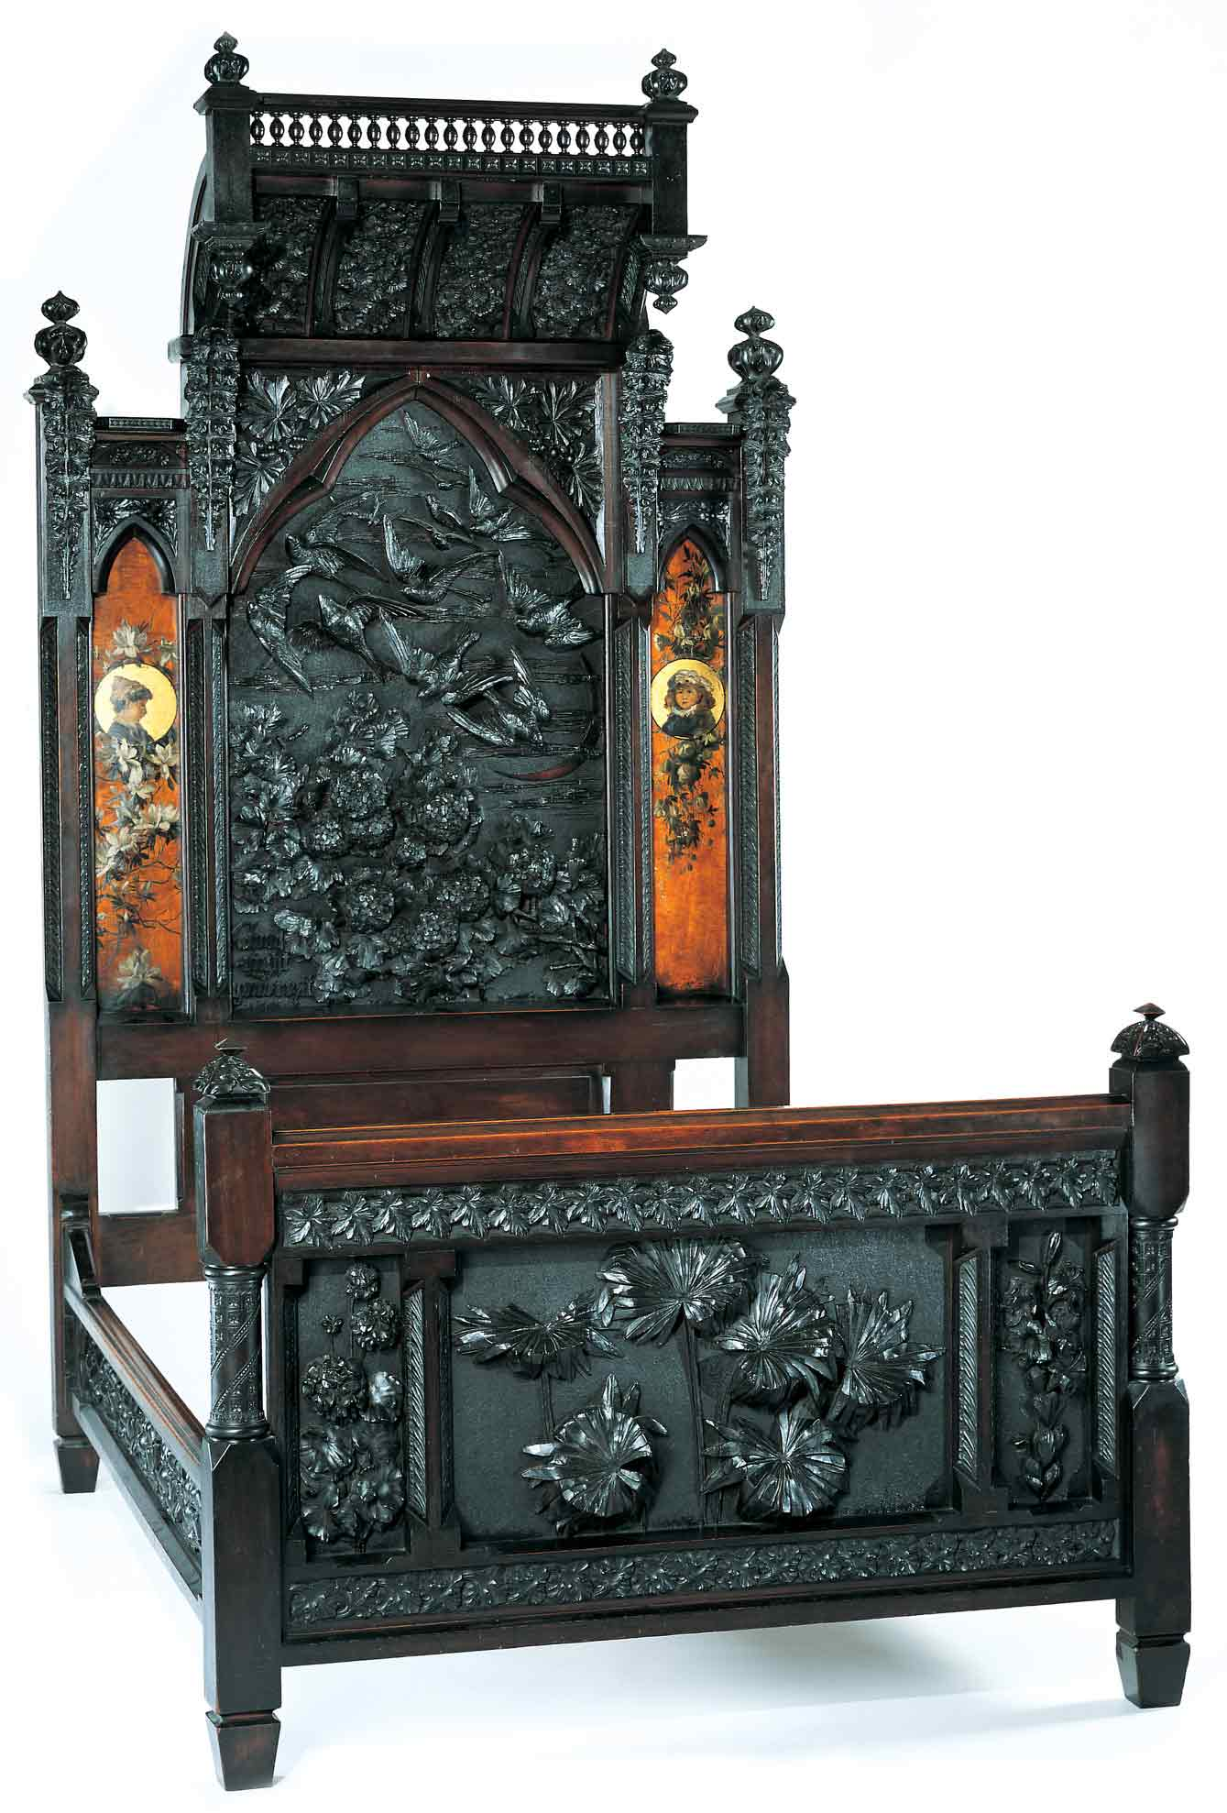
Benn Pitman (1822-1910), designer; Adelaide Nourse Pitman (1859-93), carver; and Elizabeth Nourse (1859-1938), painter
Bedstead, c. 1882-83
Gift of Mary Jane Hamilton in memory of her mother Mary Luella Hamilton, made possible through Rita S. Hudepohl, Guardian, 1994.61

Discovering the Story:
A City and Its Culture

Geometric Transformation in Interior Design

A Math Lesson for Grades 9-12

Based on Bedstead
by Benn Pitman, Adelaide Nourse Pitman and Elizabeth Nourse

Concept TC "Concept" \f C \l "1"
Using the Bedstead, the object of focus for this lesson set, students will engage in the study of 3-D geometry as represented in the placement within a room. The teacher will facilitate students in studying a hands-on application of geometrical transformation of shape through pre-conferencing lesson activities, a videoconference virtual visit with the Cincinnati Art Museum and post-conferencing lesson activities. Students will explore these concepts using inquiry instructional methods.

Objectives
Students will use 3-D geometric vocabulary in context with the transformation of shape for object placement.
Students will apply the principles of geometric transformation for the design placement of the Bedstead within an architectural floor plan/drawing of a room.
- Students will appreciate the art and design of Benn Pitman and the Nourse sisters.

Teacher Preparation
Class Periods Required
1 (30-50 min.) periods for Pre- Videoconference Lesson Activities
1 (50-min.) class period for Videoconference
1 (30-50 min.) periods for Post- Videoconference Lesson Activities

Background Information
Background Information, which contains additional details on the Bedstead and the artists who created it, has been written for teachers to review before the lesson and then share with students. The background information for the Benn Pitman bedstead is on the website at http://www.discoveringthestory.org/goldenage/bed/background.asp.

Video
Share the wood-carving video with your students prior to the videoconference. The video, which is at http://www.discoveringthestory.org/goldenage/bed/video.asp, depicts wood carver Fred Wilbur as he carves in the style of works in the Museum. He speaks at length on the Bedstead. This video is an excellent resource that will help to prepare students for the videoconference.

Video Duration – 5 minutes.

Pre- Videoconference Lesson Activities
Vocabulary

Definitions can be found in the Glossary on the Discovering the Story website at http://www.discoveringthestory.org/goldenage/bed/glossary.asp.
Architect’s scale
Clockwise rotation
Counterclockwise rotation
Dilation
Flip (reflection)
Protractor
Rotation
Slide (translation)
Transformation

Guiding Questions
- How do the characteristics of three-dimensional geometric figures affect placement of this figure in a three-dimensional space?
- How is translation (distance) and rotation (angle) measured when the location (of a bed) is moved? Why is precision important?

Materials
Picture of the Bedstead which is on the Discovering the Story website at http://www.discoveringthestory.org/goldenage/images/bedstead_full.jpg
Student copies of the Bedstead image
Copies of the sample floor plans
Protractor
Architect’s scale

Procedure
Teacher will:
- FOR HOMEWORK, ask students to measure the dimensions of their bedrooms, including ceiling height. If this is not possible, the teacher can create “example” floor plans. At least one of the floor plans should have a slanted ceiling, and windows should be included. This will demonstrate that the height of Bedstead is important in its potential placement.
- Download image of the Bedstead from the Discovering the Story website. Make a copy for each student. Have a brief discussion about the Bedstead and its creators, Benn Pitman and the Nourse sisters.
- Discuss that this downloaded image is a scale reproduction of the original, much larger, piece of furniture.
- Review use of a protractor and architect’s scale.
- Using a copy of the room’s floor plan, have the students move simple shapes from one part of the room to another part of the room. Review concepts of point-by-point translation and reflection.
- Have the students place the Bedstead at the entrance to their “room.” Using balance of design, students will locate a final placement for the bed. They will apply forms of transformation and angle to place the bed in a more appropriate place within the room. The Bedstead’s movements will be documented with the use of a protractor and architect’s scale to indicate visual placement and transformation. Students must consider that the space is three-dimensional to the height of the bed.
- Discuss why accurate measurements on scale drawings are essential for object placement.

Videoconference
Objectives
- Students will interact with the Cincinnati Art Museum staff through a sixty-minute videoconference at http://www.discoveringthestory.org/videoconference/.
- Students will learn about Cincinnati history from 1850 to 1900.
- Students will use Museum objects to reinforce activities completed in preparation for this videoconference.

Concept
A videoconference conducted by the Cincinnati Art Museum staff extends student learning through emphasis on the viewing and discussion of art objects. During this videoconference with the Museum, students will explore Cincinnati art history and the methods and practices of many of the artists working in the city.

Schedule
- 5 minutes Introduction to CAM staff (This is also buffer time in case of connection complications)

- 10 minutes Brief discussion of student pre-videoconferencing activities.

- 10 minutes Museum staff will lead an interactive discussion with students on the history of Cincinnati from 1850-1900

- 20 minutes Museum staff will lead students in an in-depth investigation of selected Museum objects.

Objects Include
- Bedstead by Benn Pitman, Adelaide Nourse Pitman, and Elizabeth Nourse. http://www.discoveringthestory.org/goldenage/images/bedstead_full.jpg
- Reception Dress by Selina Cadwallader. This image can be found at
http://www.discoveringthestory.org/goldenage/images/dress_full.jpg
- Aladdin Vase by Maria Longworth Nichols Storer, which is available at
http://www.discoveringthestory.org/goldenage/images/aladdin_full.jpg
  - Ali Baba Vase by M. Louise McLaughlin, which is available at
http://www.discoveringthestory.org/goldenage/images/alibaba_full.jpg
- Vase and Dedication Medallion by Tiffany & Co. This image is on the website at
http://www.discoveringthestory.org/goldenage/images/springer_full.jpg

- 10 minutes Questions and student sharing of art projects.

- 5 minutes Closing (This is also buffer time in case of connection complications)

Post- Videoconference Lesson Activities
Materials
- Picture of the Bedstead downloaded from www.discoveringthestory.org
- Student copies of Bedstead image
- Copies of the sample floor plans
- Protractor
- Architect’s scale

Procedure
Teacher will:
- Using the same techniques discussed in the pre-lesson, have students continue adding and moving other pieces of furniture and artwork into their “room.” They can include one or more of the vases discussed in the videoconference or other objects such as a dresser, desk, lamps, etc.
- As an extension, have the students determine how to get this Bedstead into their “room” with the starting point of a delivery truck at the entrance to their homes. Using information supplied by the Cincinnati Art Museum about the Bedstead’s construction, can the piece be taken apart, and would this help in its movement through the house?

Assessment Objectives
Students demonstrate skill while using a protractor or architect’s scale.
Students can accurately describe in mathematical terms the change in position (distance and angle).
Students can explain why accurate measurements are important when using three-dimensional geometry to show positioning of objects and movement within a space.

Academic Content Standards
National Standards: Mathematics
Standard 4: Understands and applies basic and advanced properties of the concepts of measurement.
Benchmark 3: Selects and uses an appropriate direct or indirect method of measurement in a given situation (e.g., uses properties of similar triangles to measure indirectly the height of an inaccessible object).
Benchmark 4: Solves real-world problems involving three-dimensional measures (e.g., volume, surface area).

Standard 5: Understands and applies basic and advanced properties of the concepts of geometry.
Benchmark 3: Uses synthetic representations and analytic methods to solve problems involving symmetry and transformations of figures.
Benchmark 11: Uses properties of and relationships among figures to solve mathematical and real-world problems (e.g., uses the property that the sum of the angles in a quadrilateral is equal to 360 degrees to square up the frame for a building; uses understanding of arc, chord, tangents and properties of circles to determine the radius given a circular edge of a circle without the center).

Ohio Standards: Mathematics

Geometry and Spatial Sense: Students will identify, classify, compare and analyze characteristics, properties and relationships of one-, two- and three-dimensional geometric figures and objects. Students will use spatial reasoning, properties of geometric objects and transformations to analyze mathematical situations and solve problems.
Grades 8-10
Benchmark F: Represents and models transformations in a coordinate plane and describes the results.
Benchmark G: Proves or disproves conjectures and solves problems involving two-dimensional and three-dimensional objects represented within a coordinate system.

