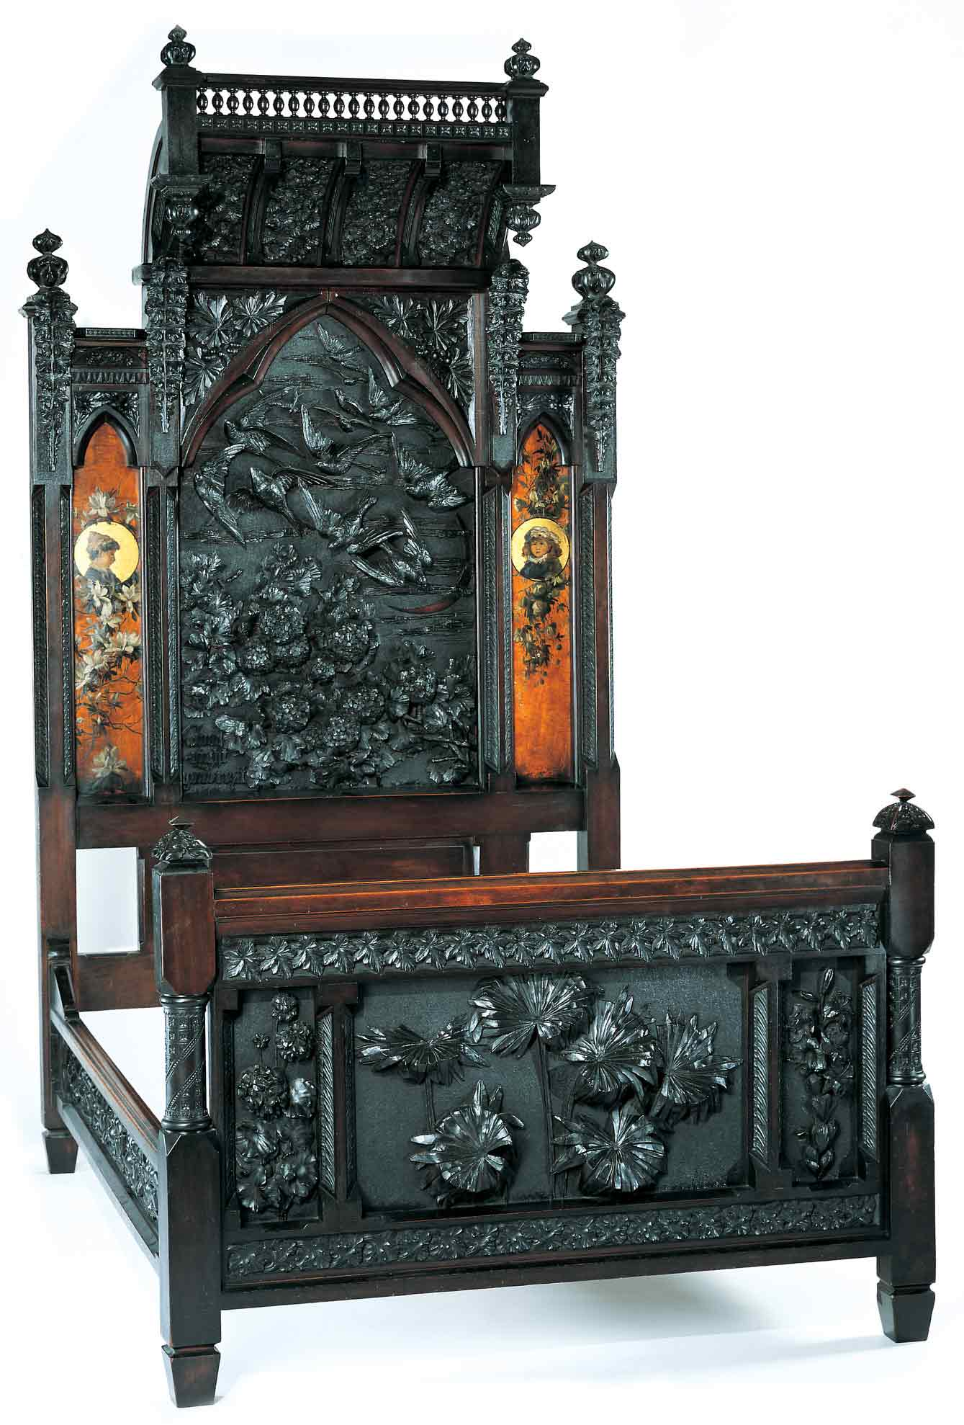
Discovering the Story:
A City and Its Culture

Nature Through Many Eyes

A Language Arts Lesson for Grades 9-12

Based on Bedstead
by Benn Pitman, Adelaide Nourse Pitman and Elizabeth Nourse

Benn Pitman (1822-1910), designer; Adelaide Nourse Pitman (1859-93), carver; and Elizabeth Nourse (1859-1938), painter
Bedstead, c. 1882-83
Gift of Mary Jane Hamilton in memory of her mother Mary Luella Hamilton, made possible through Rita S. Hudepohl, Guardian, 1994.61

Concept TC "Concept" \f C \l "1"
Many of Benn Pitman’s views were based on his philosophical mentors, John Ruskin, Ralph Waldo Emerson, and William Morris. Pitman’s ideas on the decorative arts positioned him as a staunch proponent in the forefront of the Aesthetic Movement. The teacher will facilitate student understanding through pre-videoconferencing lesson activities, a videoconference visit with the Cincinnati Art Museum, and post-videoconferencing lesson activities.

In this lesson, students will read and research the writings of Ralph Waldo Emerson and his position as one of the leading transcendentalists and proponents of the Aesthetic Movement. Students will engage in the writing process to create a creative piece in the style of Emerson that is related to the Bedstead, the Aesthetic Movement, and/or the topic of beauty in nature.

Objectives
- Students will read and appreciate various genres of literature including poetry, short stories, and novels from the Transcendentalist Movement.
- Students will demonstrate comprehension of the theories of the transcendentalists.
- Students will compose reflective writings that balance reflections by using specific personal experiences to draw conclusions about life.
- Students will appreciate the art and design of Benn Pitman and the Nourse sisters.

Teacher Preparation
Class Periods Required
1 to 2 (30-50 min.) periods for Pre-Lesson Activities
1 (50-min.) class period for Videoconference
1 to 2 (30-50 min.) periods for Post-Lesson Activities
1 to 2 (30-50 min.) periods for Art Enrichment Activity (optional)

Background Information
Background Information, which contains additional details on the Bedstead and the artists who created it, has been written for teachers to review before the lesson and then share with students. It can be found at http://www.discoveringthestory.org/goldenage/bed/background.asp.

Ralph Waldo Emerson: For more information on Emerson and the transcendentalists, advise these websites:
www.poets.org
www.transcendentalists.com
www.emersoncentral.com

John Ruskin: For more information on Ruskin and the Aesthetic Movement, advise these websites:
www.victorianweb.org/authors/ruskin/ruskinov.html
www.lancs.ac.uk/users/ruskin/default.htm

Video
Share the wood-carving video with your students prior to the videoconference. The video, which can be found on the Discovering the Story website at http://www.discoveringthestory.org/goldenage/bedstead/video.asp, depicts wood carver Fred Wilbur as he carves in the style of works in the Museum. He speaks at length on the Bedstead. This video is an excellent resource that will help to prepare students for the videoconference.

Video Duration – 5 minutes.

Pre- Videoconference Lesson Activities
Vocabulary

Definitions can be found in the Glossary on the Discovering the Story website at http://discoveringthestory.org/goldenage/bedstead/glossary.asp.

Aesthetic

Transcendentalism

Guiding Questions
- How are transcendentalism and the Aesthetic Movement similar?
- How does the viewing and study of art objects and artifacts spur further creativity in others?

Materials
- Composition books
- Resources, print and nonprint, for research purposes
- A copy of the poem The Song of Nature by Emerson (provided below)

Procedure
Teacher will:
- Have students read the background information on the Aesthetic Movement and Benn Pitman.
- Share the image of the Bedstead with students and explain to them that this piece of Cincinnati Art-Carved furniture was designed with full knowledge and accordance to the philosophies of the Aesthetic Movement.
- Introduce to students Ralph Waldo Emerson, one of Pitman’s philosophical mentors.
- Discuss with students the theories of transcendentalism.
- Initiate a conversation on how the philosophies of the Aesthetic Movement and the philosophies of the transcendentalists compare and contrast.
- Provide each student with a copy of the following poem by Emerson. Ask students to follow along as you read the poem aloud.

The Song of Nature

Mine are the night and morning,
The pits of air, the gulf of space,
The sportive sun, the gibbous moon,
The innumerable days.

I hid in the solar glory,
I am dumb in the pealing song,
I rest on the pitch of the torrent,
In slumber I am strong.

No numbers have counted my tallies,
No tribes my house can fill,
I sit by the shining Fount of Life,
And pour the deluge still;

And ever by delicate powers
Gathering along the centuries
From race on race the rarest flowers,
My wreath shall nothing miss.

And many a thousand summers
My apples ripened well,
And light from meliorating stars
With firmer glory fell.

I wrote the past in characters
Of rock and fire the scroll,
The building in the coral sea,
The planting of the coal.

And thefts from satellites and rings
And broken stars I drew,
And out of spent and aged things
I formed the world anew;

What time the gods kept carnival,
Tricked out in star and flower,
And in cramp elf and saurian forms
They swathed their too much power.

Time and Thought were my surveyors,
They laid their courses well,
They boiled the sea, and baked the layers
Or granite, marl, and shell.

But he, the man-child glorious,--
Where tarries he the while?
The rainbow shines his harbinger,
The sunset gleams his smile.

My boreal lights leap upward,
Forthright my planets roll,
And still the man-child is not born,
The summit of the whole.

Must time and tide forever run?
Will never my winds go sleep in the west?
Will never my wheels which whirl the sun
And satellites have rest?

Too much of donning and doffing,
Too slow the rainbow fades,
I weary of my robe of snow,
My leaves and my cascades;

I travail in pain for him,
My creatures travail and wait;
His couriers come by squadrons,
He comes not to the gate.

Twice I have moulded an image,
And thrice outstretched my hand,
Made one of day, and one of night,
And one of the salt sea-sand.

One in a Judaean manger,
And one by Avon stream,
One over against the mouths of Nile,
And one in the Academe.

I moulded kings and saviours,
And bards o'er kings to rule;--
But fell the starry influence short,
The cup was never full.

Yet whirl the glowing wheels once more,
And mix the bowl again;
Seethe, fate! the ancient elements,
Heat, cold, wet, dry, and peace, and pain.

Let war and trade and creeds and song
Blend, ripen race on race,
The sunburnt world a man shall breed
Of all the zones, and countless days.

No ray is dimmed, no atom worn,
My oldest force is good as new,
And the fresh rose on yonder thorn
Gives back the bending heavens in dew.

From American Poetry: The Nineteenth Century, Volume I, published by Library of America.

- After reading the poem by Emerson, break students into small groups.
- Have each group reread the poem and identify what Emerson is saying about nature and how this aligns with the philosophies of the Aesthetic Movement and the transcendentalists. Also, how it aligns with the images on the Bedstead.
- Have students create a list of questions on these topics for the Cincinnati Art Museum staff to be answered during the videoconference. Email the students’ questions to emily.holtrop@cincyart.org at the Museum prior to the videoconference.
- Carry out the Art Enrichment Activity for student creation.

Videoconference

Objectives
- Students will interact with the Cincinnati Art Museum staff through a sixty-minute videoconference. Information is at http://www.discoveringthestory.org/videoconference/.
- Students will learn about Cincinnati history from 1850 to 1900.
- Students will use Museum objects to reinforce activities completed in preparation for this videoconference.

Concept
A videoconference conducted by the Cincinnati Art Museum staff extends student learning through emphasis on the viewing and discussion of art objects. During this videoconference with the Museum, students will explore Cincinnati art history and the methods and practices of many of the artists working in the city.

Schedule
- 5 minutes Introduction to CAM staff (This is also buffer time in case of connection complications)

- 10 minutes Brief discussion of student pre-videoconferencing activities.

- 10 minutes Museum staff will lead an interactive discussion with students on the history of Cincinnati from 1850-1900

- 20 minutes Museum staff will lead students in an in-depth investigation of selected Museum objects.

Objects Include:
- Bedstead by Benn Pitman, Adelaide Nourse Pitman, and Elizabeth Nourse. http://www.discoveringthestory.org/goldenage/images/bedstead_full.jpg
- Reception Dress by Selina Cadwallader. This image can be found at
http://www.discoveringthestory.org/goldenage/images/dress_full.jpg
- Aladdin Vase by Maria Longworth Nichols Storer, which is available at
http://www.discoveringthestory.org/goldenage/images/aladdin_full.jpg
  - Ali Baba Vase by M. Louise McLaughlin, which is available at
http://www.discoveringthestory.org/goldenage/images/alibaba_full.jpg
- Vase and Dedication Medallion by Tiffany & Co. This image is on the Website at
http://www.discoveringthestory.org/goldenage/images/springer_full.jpg

- 10 minutes Questions and student sharing of art projects.

- 5 minutes Closing (This is also buffer time in case of connection complications)

Post- Videoconference Lesson Activities

Materials
- Composition notebook
- Authoring or presentation software if completed electronically

Procedure
Teacher will:
- With the knowledge obtained during the pre-videoconferencing lesson activities and the videoconference with the Cincinnati Art Museum, students will now read and research other writings by Emerson and his fellow transcendentalists.
- Websites for more information on Emerson:
www.poets.org
www.transcendentalists.com
www.emersoncentral.com
- Have students discuss how Emerson and Pitman expressed their concern and feelings about nature. How are similar ideas represented in different forms (literary vs. furniture)?
- Have students discuss in small or large groups what inspires them about nature. Engage students in the creative writing process to write about their personal experiences with their natural outdoor environment. They may choose to write a poem, a short story, or in a journal.

Assessment Objectives
- Students demonstrate an understanding of the Aesthetic Movement.
- Students demonstrate an understanding of transcendentalism.
- Students are able to follow multiple directions.
- Students are able to research and obtain factual information.
- Students are able to write poem in the style of Emerson.

Academic Content Standards
National Standards: Language Arts - Reading
Standard 6: Uses reading skills and strategies to understand and interpret a variety of literary texts.
Grades 9-12
Benchmark 1: Uses reading skills and strategies to understand a variety of literary texts.
Benchmark 2: Knows the defining characteristics of a variety of literary forms and genres.
Benchmark 6: Understands how themes are used across literary works and genres.
Benchmark 7: Understands the effects of author's style and complex literary devices and techniques on the overall quality of a work.
Benchmark 8: Understands relationships between literature and its historical period, culture, and society.

National Standards: Language Arts - Writing

Standard 1: Uses the general skills and strategies of the writing process.
Grades 9-12

Standard 2: Uses the stylistic and rhetorical aspects of writing.
Grades 9-12
Benchmark 1: Prewriting: Uses a variety of prewriting strategies.
Benchmark 2: Drafting and Revising: Uses a variety of strategies to draft and revise written work.
Benchmark 3: Editing and Publishing: Uses a variety of strategies to edit and publish written work.
Benchmark 4: Evaluates own and others' writing.
Benchmark 5: Uses strategies to address writing to different audiences.
Benchmark 6: Uses strategies to adapt writing for different purposes.

Standard 3: Uses grammatical and mechanical conventions in written compositions.
Grades 9-12
Benchmark 1: Uses conventions of print in writing.
Benchmark 2: Uses complete sentences in written compositions.
Benchmark 3: Uses declarative and interrogative sentences in written compositions.
Benchmark 4: Uses nouns in written compositions.
Benchmark 5: Uses verbs in written compositions.
Benchmark 7: Uses adverbs in written compositions.
Benchmark 8: Uses conventions of spelling in written compositions.
Benchmark 9: Uses conventions of capitalization in written compositions.
Benchmark 10: Uses conventions of punctuation in written compositions.

Standard 4: Gathers and uses information for research purposes.
Grades 9-12
Benchmark 1: Uses appropriate research methodology.
Benchmark 2: Uses a variety of print and electronic sources to gather information for research topics.
Benchmark 3: Uses a variety of primary sources to gather information for research topics.
Benchmark 4: Uses a variety of criteria to evaluate the validity and reliability of primary and secondary source information.
Benchmark 5: Synthesizes information from multiple research studies to draw conclusions that go beyond those found in any of the individual studies.

National Standards: Visual Arts
Standard 4: Understands the visual arts in relation to history and cultures.
Grades 9-12
Benchmark 1: Knows a variety of historical and cultural contexts regarding characteristics and purposes of works of art.
Benchmark 2: Knows the function and meaning of specific art objects within varied cultures, times, and places.
Benchmark 3: Understands relationships among works of art in terms of history, aesthetics, and culture.

Ohio Standards: Language Arts
Reading Applications
Literary Text: Students enhance their understanding of the human story by reading literary texts that represent a variety of authors, cultures, and eras. They learn to apply the reading process to the various genres of literature, including fables, folk tales, short stories, novels, poetry, and drama. They demonstrate their comprehension by describing and discussing the elements of literature (e.g., setting, character, and plot), analyzing the author’s use of language (e.g., word choice and figurative language), comparing and contrasting texts, inferring theme and meaning, and responding to text in critical and creative ways. Strategic readers learn to explain, analyze, and critique literary text to achieve deep understanding.

Grades 8-10
Benchmark A: Identifies similar recurring themes across different works.
Benchmark C: Identifies and analyzes how an author uses figurative language, sound devices, and literary techniques to shape plot, set meaning, and develop tone.
Benchmark D: Explains techniques used by authors to develop style.

Writing Process: Students’ writing develops when they regularly engage in the major phases of the writing process. The writing process includes the phases of prewriting, drafting, revising and editing, and publishing. They learn to plan their writing for different purposes and audiences. They learn to apply their writing skills in increasingly sophisticated ways to create and produce compositions that reflect effective word and grammatical choices. Students develop revision strategies to improve the content, organization, and language of their writing. Students also develop editing skills to improve writing conventions.

Grades 8-10
Benchmark A: Formulates writing ideas and identifies a topic appropriate to the purpose and audience.
Benchmark B: Determines the usefulness of organizers and applies appropriate pre- writing tasks.
Benchmark C: Uses revision strategies to improve the style, variety of sentence structure, clarity of the controlling idea, logic, effectiveness of word choice, and transitions between paragraphs, passages, or ideas.
Benchmark D: Edits to improve sentence fluency, grammar, and usage.
Benchmark E: Applies tools to judge the quality of writing.
Benchmark F: Prepares writing for publication that is legible, follows an appropriate format, and uses techniques such as electronic resources and graphics.

Research Standard: Students define and investigate self-selected or assigned issues, topics, and problems. They locate, select, and make use of relevant information from a variety of media, reference, and technological sources. Students use an appropriate form to communicate their findings.
Grades 8–10
Benchmark A: Formulates open-ended research questions suitable for investigation and adjusts questions as necessary while research is conducted.
Benchmark B: Evaluates the usefulness and credibility of data and sources.

Ohio Standards: Visual Arts

Historical, Cultural, and Social Contexts: Students understand the impact of visual art on history, culture, and society from which it emanates. They understand the cultural, social, and political forces that, in turn, shape visual art communication and expression. Students identify the significant contributions of visual artists to cultural heritage. They analyze the historical, cultural, social, and political contexts that influence the function and role of visual art in the lives of people.

Grades 9-12

Benchmark A: Explains how and why visual art forms develop in the context in which they were made.

Benchmark C: Explains the characteristics and content of culturally and historically representative artworks to demonstrate understanding of how visual art reflects historical issues, events, and cultural traditions.

Analyzing and Responding: Students identify and discriminate themes, media, subject matter, and formal technical and expressive aspects in works of art. They understand and use the vocabulary of art criticism to describe visual feature, analyze relationships, and interpret meanings in works of art. Students make judgments about the quality of works of art using the appropriate criteria.

Grades 9-12

Benchmark A: Applies the knowledge and skills of art criticism to conduct in-depth analyses of works of art.

