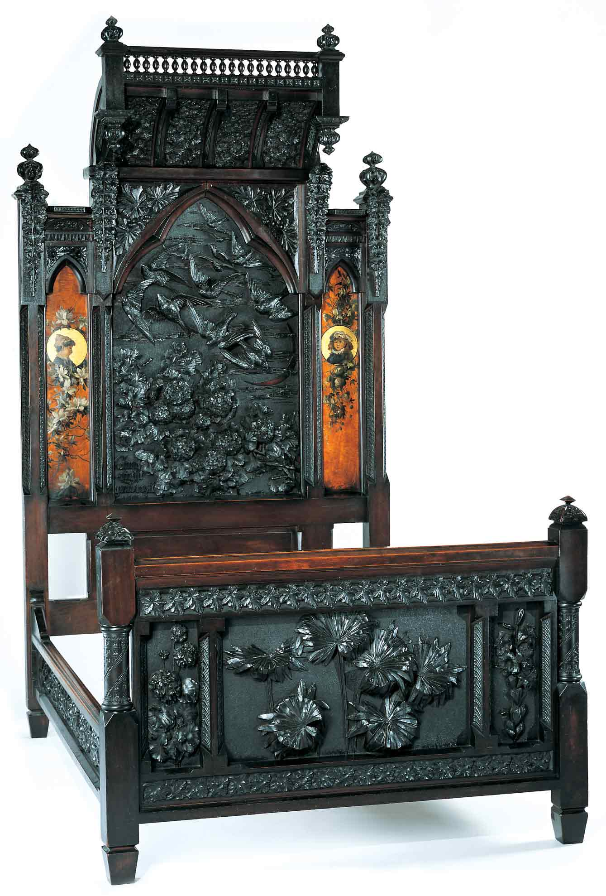
Discovering the Story:
A City and Its Culture

Ecosystems in Art

A Science Lesson for
Grades 4-8

Based on Bedstead
by Benn Pitman, Adelaide Nourse Pitman and Elizabeth Nourse

Benn Pitman (1822-1910), designer; Adelaide Nourse Pitman (1859-93), carver; and Elizabeth Nourse (1859-1938), painter
Bedstead, c. 1882-83
Gift of Mary Jane Hamilton in memory of her mother Mary Luella Hamilton, made possible through Rita S. Hudepohl, Guardian, 1994.61

Concept TC "Concept" \f C \l "1"

The Bedstead incorporates high-relief carvings of various plants and trees indigenous to the natural habitats of the Cincinnati area. The teacher will facilitate students in the investigation of the interdependent relationship of plants within a local backyard mini-ecosystem. Teachers will also lead in the identification of these plants through pre-videoconferencing lesson activities, a videoconference visit with the Cincinnati Art Museum, and post-videoconferencing lesson activities. Students, through this lesson, will practice the skill of inquiry, direct observation, and scientific note-taking for the study of natural environments, as well as develop an appreciation of living things found both in nature and in art.

Objectives
- Students will appreciate the art and design of Benn Pitman and the Nourse sisters.
- Students will examine the interdependency of living things in a local mini-ecosystem. (NAS Standard 6/Benchmark 1 – OAS)
Students will gather, compile, and record observational data of a local ecosystem in the format of a scientific journal. (NAS Standard 12/Benchmark 3 – OAS)

Teacher Preparation
Class Periods Required
1 to 2 (30-50 min.) periods for Pre-Lesson Activities
1 50-min. class period for Videoconference
1 week for extended Post-Lesson Activities
1 to 2 (30-50 min.) periods for Art Enrichment Activity (optional)

Background Information
Background Information, which contains additional details on the Bedstead and the artists who created it, has been written for teachers to review before the lesson and then share with students. The information is at http://www.discoveringthestory.org/goldenage/bed/background.asp.

Video
Share the wood-carving video with your students prior to the videoconference. The video, which is on the website at http://www.discoveringthestory.org/goldenage/bed/video.asp, depicts wood carver Fred Wilbur as he carves in the style of works in the Museum. He speaks at length on the Bedstead. This video is an excellent resource that will help to prepare students for the videoconference. Video Duration – 5 minutes.

Pre- Videoconference Lesson Activities
Vocabulary

Definitions can be found in the Glossary on the Discovering the Story Website at http://www.discoveringthestory.org/goldenage/bedstead/glossary.asp.
Adornment
Ecosystem
Energy
Flora
Fauna
Habitat
Natural/Native
Organisms
Photosynthesis
Guiding Questions
- What is an ecosystem?
- What are the roles of living organisms in an ecosystem?
- What are the roles of plants and trees in an ecosystem?
- What do living organisms need for growth and survival?
- What happens when there are changes in the systems and energy forces of an environment?

Materials

Print and/or download the following digital images. You should have a detail image from the Bedstead and a real-life image of each of the following plants:
Azalea
Bedstead Image:
http://www.discoveringthestory.org/goldenage/images/bed_azalea_full.jpg
Real-life Image:
http://www.discoveringthestory.org/goldenage/images/real_azalea_full.jpg
Balloon Vine
Bedstead Image:
http://www.discoveringthestory.org/goldenage/images/bed_balloon_full.jpg
Real-life Image:
http://www.discoveringthestory.org/goldenage/images/real_balloon_full.jpg
Daisy
Bedstead Image: http://www.discoveringthestory.org/goldenage/images/bed_daisy_full.jpg
Real-life Image: http://www.discoveringthestory.org/goldenage/images/real_daisy_full.jpg
Daylily
Bedstead Image: http://www.discoveringthestory.org/goldenage/images/bed_daylily_full.jpg
Real-life Image: http://www.discoveringthestory.org/goldenage/images/real_daylily_full.jpg
Geranium
Bedstead Image: http://www.discoveringthestory.org/goldenage/images/bed_geranium_full.jpg
Real-life Image: http://www.discoveringthestory.org/goldenage/images/real_geranium_full.jpg
Hydrangea
Bedstead Image: http://www.discoveringthestory.org/goldenage/images/bed_hydrangea_full.jpg
Real-life Image: http://www.discoveringthestory.org/goldenage/images/real_hydrangea_full.jpg
Palmetto (Palmeris)
Bedstead Image: http://www.discoveringthestory.org/goldenage/images/bed_palmetto_full.jpg
Real-life Image: http://www.discoveringthestory.org/goldenage/images/real_palmetto_full.jpg
Wild Parsnip
Bedstead Image: http://www.discoveringthestory.org/goldenage/images/bed_wild_parsnip_full.jpg
Real-life Image: http://www.discoveringthestory.org/goldenage/images/real_wild_parsnip_full.jpg
Poppy
Bedstead Image: http://www.discoveringthestory.org/goldenage/images/bed_poppy_full.jpg
Real-life Image: http://www.discoveringthestory.org/goldenage/images/real_poppy_full.jpg
Wild Rose
Bedstead Image: http://www.discoveringthestory.org/goldenage/images/bed_wild_rose_full.jpg
Real-life Image: http://www.discoveringthestory.org/goldenage/images/real_wild_rose_full.jpg
Visual of the Bedstead at http://www.discoveringthestory.org/goldenage/images/bedstead_full.jpg

Procedure
Teacher will:
- Use the guiding questions to lead a discussion on living things and ecosystems.
- Review with students what a living thing, like a plant, needs to survive – water, oxygen, sunlight, and food.
- Review with students the aspects of ecosystems and what an ecosystem needs to thrive.
- Tell students that they are going to closely investigate an object that was made from a living thing (a tree) and that is covered with depictions of living things (plants and animals).
- Introduce students to a visual of the Bedstead.
- Share with students the detail images of the plant and animal representations from the Bedstead, as listed in “Materials” on the previous page.
- Share with students the images of the real-life plants and animals represented on the Bedstead, as listed in “Materials” on the previous page.
- Have students match the plant representations from the Bedstead with its real-life image.
- Ask students to consider the plants and animals as depicted on the Bedstead as an ecosystem. What would this ecosystem need to thrive? How does each member of the ecosystem affect the other members?
- Ask students whether the plants and animals on the Bedstead look like the real-life images. Why would they look different? Do they think the people who designed and carved the Bedstead looked at actual plants for inspiration? Tell them that they will get a chance to ask that question when they meet the people from the Cincinnati Art Museum during the videoconference.

Videoconference
Objectives
- Students will interact with the Cincinnati Art Museum staff through a sixty-minute videoconference. Information is at http://www.discoveringthestory.org/videoconference/.
- Students will learn about Cincinnati history from 1850 to 1900.
- Students will use Museum objects to reinforce activities completed in preparation for this videoconference.

Concept
A videoconference conducted by the Cincinnati Art Museum staff extends student learning through emphasis on the viewing and discussion of art objects. During this videoconference with the Museum, students will explore Cincinnati art history and the methods and practices of many of the artists working in the city.

Schedule
- 5 minutes Introduction to CAM staff (This is also buffer time in case of connection complications)

- 10 minutes Brief discussion of student pre-videoconferencing activities.

- 10 minutes Museum staff will lead an interactive discussion with students on the history of Cincinnati from 1850-1900

- 20 minutes Museum staff will lead students in an in-depth investigation of selected Museum objects.

Objects Include
- Bedstead by Benn Pitman, Adelaide Nourse Pitman, and Elizabeth Nourse. http://www.discoveringthestory.org/goldenage/images/bedstead_full.jpg
- Reception Dress by Selina Cadwallader. This image can be found at
http://www.discoveringthestory.org/goldenage/images/dress_full.jpg
- Aladdin Vase by Maria Longworth Nichols Storer, which is available at
http://www.discoveringthestory.org/goldenage/images/aladdin_full.jpg
  - Ali Baba Vase by M. Louise McLaughlin, which is available at
http://www.discoveringthestory.org/goldenage/images/alibaba_full.jpg
- Vase and Dedication Medallion by Tiffany & Co. This image is on the Website at
http://www.discoveringthestory.org/goldenage/images/springer_full.jpg

- 10 minutes Questions and student sharing of art projects.

- 5 minutes Closing (This is also buffer time in case of connection complications)

Post- Videoconference Lesson Activities
Materials
- Composition notebook
- Drawing and writing tools
- Handout A (which can be found at the end of this lesson)
- Clipboards (one per student)

Procedure
Teacher will:
- View the wood-carving video with class. Inform students that in order to make realistic representations of living things, Mr. Wilbur is required to closely observe those things in nature. Explain to students the purpose of a class nature walk to conduct personal observations and identifications of living things just like Mr. Wilbur.
- Guide students on a nature walk in a nearby park or nature preserve. Ask students to observe the interdependency of living organisms, with emphasis on native plants and trees within a specified square footage.
- Have students conduct observations and include a sketch of the observed area.
- Have students record their findings as scientific journal entries in a composition notebook. Introduce students to authentic scientific journal notation.
- Use of pen and paper for note-taking
- Recording entries with date, time, and location
- Use of drawings, sketches, and photos
- Counting and recording of the number of living organisms within a given area, etc.
- Have students include the time of day, season of the year, weather conditions, and the count of observed native plants and their growth, and too, animals living in the designated area.
- Have students identify the source and flow of energy –light, air, water--within their mini-ecosystem, evidence of photosynthesis, and the interdependent relationships between plants, trees, and animals in the observed area.
- Have students infer changes that would occur if the energy flow or interdependent relationship were disturbed. (Additional notes, drawings, sketches, samples, etc., may be added to the notebook.)
- Debrief on return to the classroom, student observations of the local ecosystem and the number of native plants and trees within the habitat. Have students compare findings to the flora and fauna on the Bedstead.
- Lead student discussion on the reality for survival of the Bedstead ecosystem to that personally observed in the field.
- Have students continue to gather observational data of native plants and trees and their surrounding mini-ecosystem to identify visible changes due to the time of day, weather changes, and interactions with other living things--humans and other animals. Observation entries also include other identified living organisms within the mini-ecosystem.

Lesson extensions:
- Students plant a small garden on school grounds, create jar terrariums, or create a rotting log environment in a fish tank to develop a living ecosystem/habitat.
- Students observe and record growth, flow of energy, transfer of energy, and change of that environment.

Assessment Objectives
- Students will have accurate journal entries.
- Students can define an ecosystem and environmental influences.
- Students can define photosynthesis and energy flow.
- Students can define the interdependency of organisms.
- Students can identify Benn Pitman, the Nourse sisters, and the Pitman Bedstead.
- Students will write a brief narrative on the benefits of field observation for the study of environmental settings.

Academic Content Standards
National Standards: Science
Life Sciences
Standard 6: Understands relationships among organisms and their physical environments.

Grades 3-5
Benchmark 1: Knows the organization of simple food chains and food webs (e.g., green plants make their own food with sunlight, water, and air; some animals eat the plants; some animals eat the animals that eat the plants).

Nature of Science
Standard 12: Understands the nature of scientific inquiry.

Grades 3-5
Benchmark 1: Knows that scientific investigations involve asking and answering a question and comparing the answer to what scientists already know about the world.
Benchmark 2: Knows that scientists use different kinds of investigations (e.g., naturalistic observation of things or events, data collection, controlled experiments), depending on the questions they are trying to answer.

National Standards: Visual Arts
Standard 4: Understands the visual arts in relation to history and cultures.

Grades 5-8
Benchmark 1: Understands similarities and differences among the characteristics of artworks from various eras and cultures.
Benchmark 2: Understands the historical and cultural contexts of a variety of art objects.
Benchmark 3: Understands how factors of time and place influence visual, spatial, or temporal characteristics that give meaning or function to a work of art

Ohio Standards: Science
Life Science: Students demonstrate an understanding of how living systems function and how they interact with the physical environment. This includes an understanding of the cycling of matter and flow of energy in living systems. An understanding of the characteristics, structure, and function of cells, organisms, and living systems will be developed. Students will also develop a deeper understanding of the principles of heredity, biological evolution, and the diversity and interdependence of life. Students demonstrate an understanding of different historical perspectives, scientific approaches, and emerging scientific issues associated with the life sciences.

Grades 3-5
Benchmark B: Analyzes plant and animal structures and functions needed for survival and describes the flow of energy through a system that all organisms use to survive.
Benchmark C: Compares changes in an organism's ecosystem/ habitat that affect its survival.

Scientific Inquiry: Students develop scientific habits of mind as they use the processes of scientific inquiry to ask valid questions and to gather and analyze information. They understand how to develop hypotheses and make predictions. They are able to reflect on scientific practices as they develop plans of action to create and evaluate a variety of conclusions. Students are also able to demonstrate the ability to communicate their findings to others.

Grades 3-5
Benchmark A: Uses appropriate instruments safely to observe, measure, and collect data when conducting a scientific investigation.
Benchmark B: Organizes and evaluates observations, measurements, and other data to formulate inferences and conclusions.
Benchmark C: Develops, designs, and safely conducts scientific investigations and communicates the results.

Ohio Standards: Visual Arts

Historical, Cultural, and Social Contexts: Students understand the impact of visual art on history, culture, and society from which it emanates. They understand the cultural, social, and political forces that, in turn, shape visual art communication and expression. Students identify the significant contributions of visual artists to cultural heritage. They analyze the historical, cultural, social, and political contexts that influence the function and role of visual art in people’s lives.

Grades 5-8

Benchmark A: Compares and contrasts the distinctive characteristics of art forms from various cultural, historical, and social contexts.

Benchmark D: Researches culturally or historically significant works of art and discusses their roles in society, history, culture, or politics.

Analyzing and Responding: Students identify and discriminate themes, media, subject matter, and formal technical and expressive aspects in works of art. They understand and use the vocabulary of art criticism to describe visual features, analyze relationships, and interpret meanings in works of art. Students make judgments about the quality of works of art using the appropriate criteria.
Grades 5-8
Benchmark A: Applies the strategies of art criticism to describe, analyze, and interpret selected works of art.

Handout A

Field Observation

Name

This is the living thing I see

I see evidence of…
Sunlight | Water |  | Air |  | Soil
Rubbing |  | Seed Sample |  | Leaf Sample

