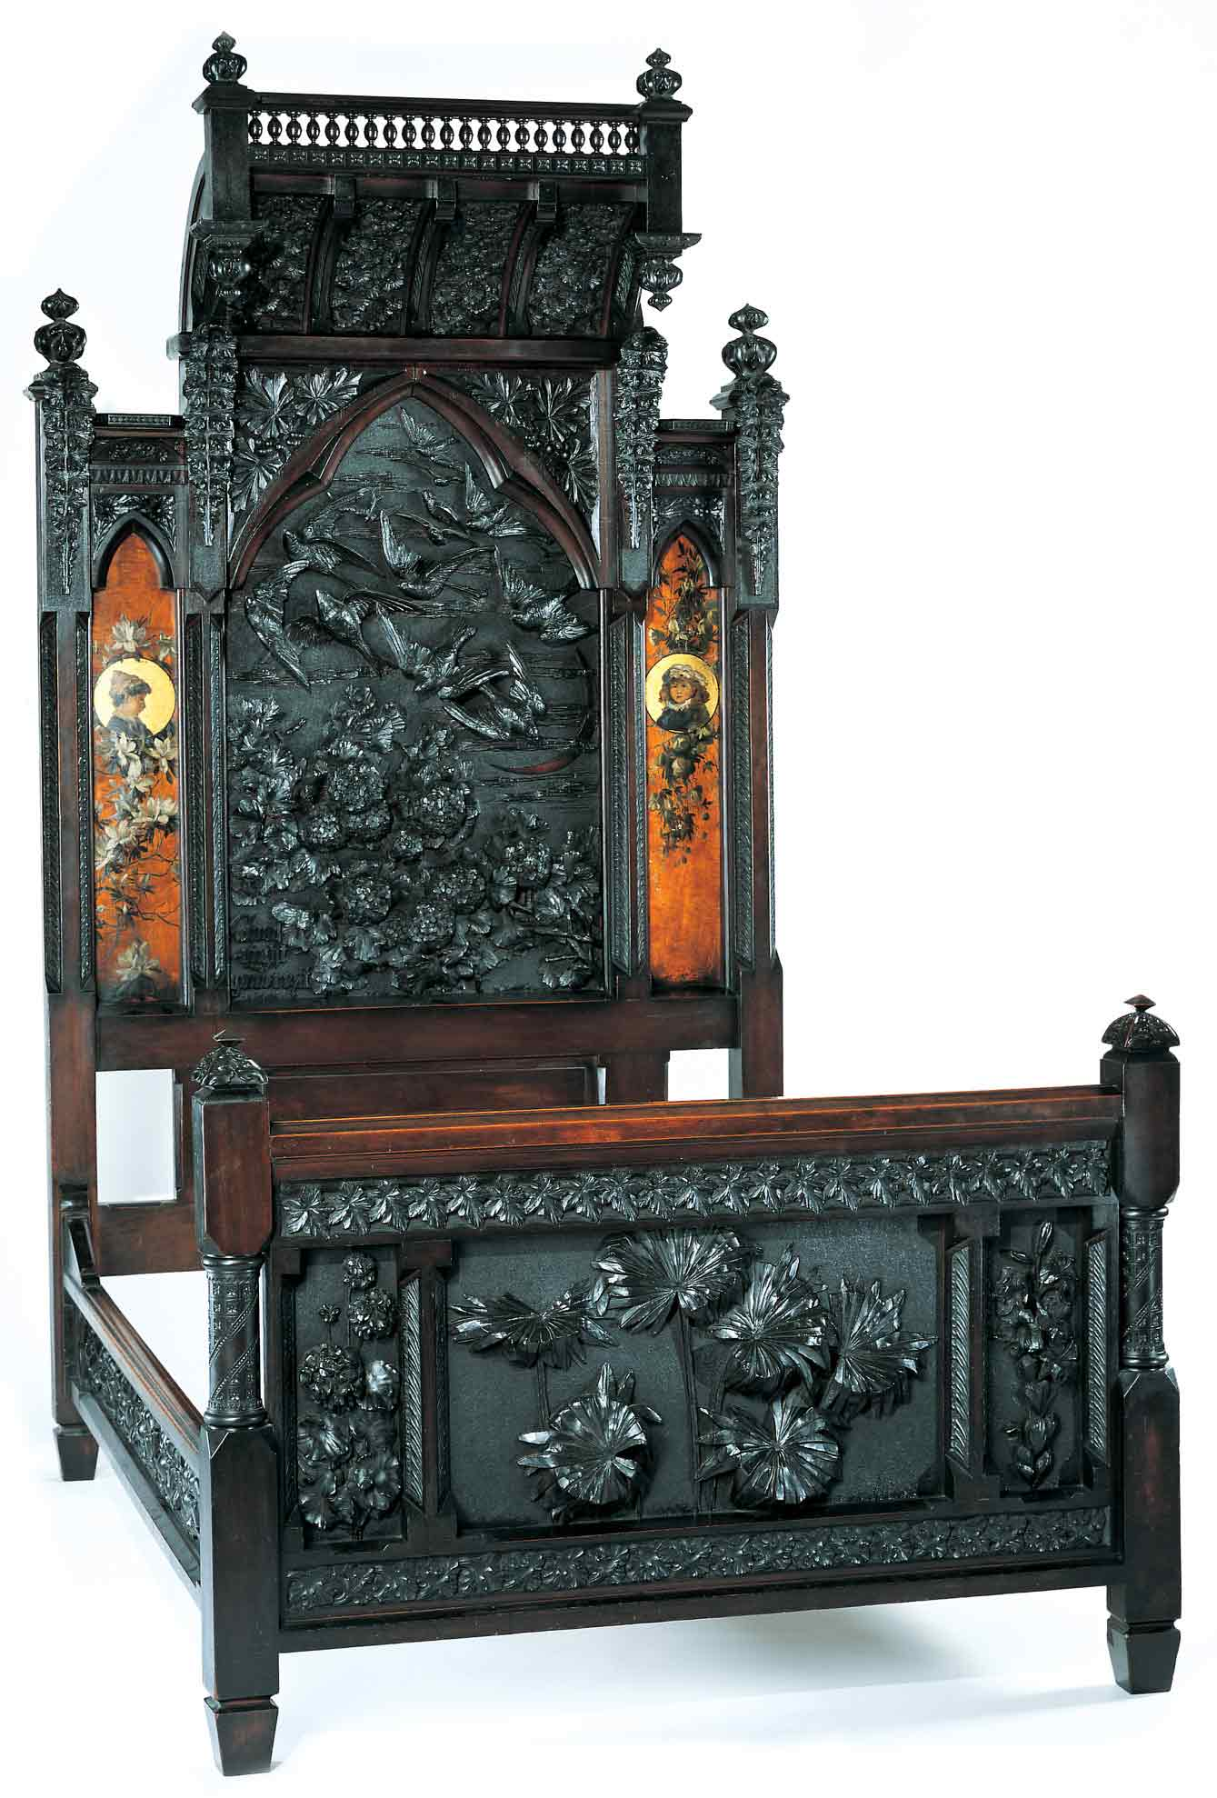
Discovering the Story:
A City and Its Culture

Cincinnati’s Women Artists

A Social Studies Lesson for Grades 4-8

Based on Bedstead
by Benn Pitman, Adelaide Nourse Pitman and Elizabeth Nourse

Benn Pitman (1822-1910), designer; Adelaide Nourse Pitman (1859-93), carver; and Elizabeth Nourse (1859-1938), painter
Bedstead, c. 1882-83
Gift of Mary Jane Hamilton in memory of her mother Mary Luella Hamilton, made possible through Rita S. Hudepohl, Guardian, 1994.61

Concept TC "Concept" \f C \l "1"

Introduction to the historical role of Cincinnati as a leader in the global art community and the development of art education will lead to student recognition of the significance of the Pitman Bedstead, designed in the late 1800s, and carved and painted by women artists.

The teacher will facilitate students in study and hands-on applications through pre-videoconferencing classroom activities, a videoconference visit with the Cincinnati Art Museum, and post-videoconferencing lesson activities. Emphasis is on student representation of information about women artists in the form of a time line.

Objectives
- Students will conduct biographical inquiry using primary and secondary resources to explore the lives and contributions of women artists in society.
- Students will understand the organization of that information in the form of a time line.
- Students will examine the lives, works, and impact of key artists and art works representative of Cincinnati history – Benn Pitman, Adelaide Nourse Pitman, Elizabeth Nourse, and the Pitman Bedstead.
- Students will explore how art museums and public art collect and exhibit historical art works and art developments, and how they foster public education over time.

Teacher Preparation
Class Periods Required
1 to 2 (30-50 min.) periods for Pre-Lesson Activities
1 50-min. class period for Videoconference
1 week for extended Post-Lesson Activities
1 to 2 (30-50 min.) periods for Art Enrichment Activity (optional)

Background Information
Background Information, on the Discovering the Story website at http://www.discoveringthestory.org/goldenage/bed/background.asp, contains additional details on the Bedstead and the artists who created it and has been written for teachers to review before the lesson and then share with students.

Video
Share the wood-carving video with your students prior to the videoconference. The video, on the website at http://www.discoveringthestory.org/goldenage/bed/video.asp, depicts wood carver Fred Wilbur as he carves in the style of works in the Museum. He speaks at length on the Bedstead. This video is an excellent resource that will help to prepare students for the videoconference. Video Duration – 5 minutes.

Pre- Videoconference Lesson Activities

Vocabulary

Definitions can be found in the Glossary on the Discovering the Story website at http://www.discoveringthestory.org/goldenage/bedstead/glossary.asp.
Autobiography
Biography
Chronological Order
Primary source
Secondary source
Time line
Guiding Questions
- What is a time line?
- What is the function of a time line?
- Why is the understanding of time lines important to the study of history? Of art history?
- Why is it important to research events in United States and world history as they relate to the Bedstead?

Materials

- Library collection of print, nonprint, primary, secondary, and technology sources for student inquiry
- Printed/downloaded images from the Discovering the Story website at http://www.discoveringthestory.org/videoconference/photos.asp.

Artist profiles of Adelaide Nourse Pitman, Elizabeth Nourse, and Benn Pitman printed/downloaded from the background page on the Discovering the Story website.

Procedure
Teacher will:
- Encourage students to brainstorm names of as many artists as they can and record those names for viewing by all students.
- Review the list with students.
- Ask students what the artists have in common (e.g., gender, ethnicity, age, geographical representation, type of artist, kind of art produced, etc.).
- Facilitate student discussion on the role of gender in art.
- Have students identify any female artists from the prior listing. If none, discuss why.
Female achievements in art have historically been overlooked. Ask them why that is.
- Explain that to better understand female achievements in art and history, the class will study art created by two women who once lived in Cincinnati, Ohio – Adelaide Nourse Pitman and Elizabeth Nourse.
- Introduce students to a picture of the Bedstead. Ask students if they think the Bedstead is art. Inform students that a woman artist (a twin sister) actually carved this bed out of one large tree trunk. The other woman/twin painted the pictures on it.
- Introduce students to the artists Benn Pitman, Adelaide Nourse Pitman, and Elizabeth Nourse. Emphasize highlights of their lives and contributions to the Cincinnati community.
- Share with students in particular the artist profiles of Adelaide Nourse Pitman and Elizabeth Nourse. Because this information was written for teacher preparatory work, teacher may want to summarize this information for students and not read it aloud to the class.
- Facilitate student discussion on the fact that these women/sisters were considered artists and wood carving/painting was their profession. Emphasize that both women contributed to their community by decorating furniture.
- View with students the Fred Wilbur video to illustrate the craft of wood carving used by the Nourse sisters.
- Inform students that they are going to conduct a biographical research project on a female artist and will represent findings of the artist’s life in the format of a biographical narrative accompanied by a sketch of the artist.
- Divide students into two teams. One team will research the life of Adelaide Nourse Pittman and the other will research the life of Elizabeth Nourse. It is important to remember and to remind students that these two ladies were twin sisters and much of the research on the two individuals will overlap.
- Facilitate use of the following question prompts to guide the student teams’ research.
- Have each team answer the questions below. Students may brainstorm and decide how best to work collaboratively and divide responsibility for the work.
Questions
- When and where was the artist born?
- What important events happened in her early life that had long-term impact?
- What people were of importance in her life? How did they influence her? What impact did they have? Did she meet them? If so, when?
- Where and when did she learn her craft? Did she attend a specific school to learn her craft? If so, when and where?
- What other kinds of work did she do? Where and when did she do this work?
- To what important places did the person travel? When and why did she travel there?
- What honors or awards were bestowed upon the person during her lifetime? Why and when were these honors bestowed upon her?
- Where, when, and how did she die?
- Instruct students in the desired format for recording found information and its final presentation as a biographical narrative.
- Have students conduct research and create a final document for their findings with the aid of various resources--print, nonprint, primary, and secondary.
- Introduce concepts and working definitions for informational resources.
- Inform students of their participation in a videoconference with CAM staff, through which additional information will be obtained about the Nourse sisters, Benn Pitman, and the Pitman Bedstead.
- Individually or as a class, have students create a list of questions to ask the CAM staff
about the Nourse sisters and the Bedstead during a scheduled videoconference.
- Fax or email these questions to the Cincinnati Art Museum: emily.holtrop@cincyart.org . If time allows, the videoconferencing instructor will answer student questions.

Videoconference
Objectives
- Students will interact with the Cincinnati Art Museum staff through a sixty-minute videoconference.
- Students will learn about Cincinnati history from 1850 to 1900.
- Students will use Museum objects to reinforce activities completed in preparation for this videoconference.

Concept
A videoconference conducted by the Cincinnati Art Museum staff extends student learning through emphasis on the viewing and discussion of art objects. During this videoconference with the Museum, students will explore Cincinnati art history and the methods and practices of many of the artists working in the city.

Schedule
- 5 minutes Introduction to CAM staff (This is also buffer time in case of connection complications)

- 10 minutes Brief discussion of student pre-videoconferencing activities.

- 10 minutes Museum staff will lead an interactive discussion with students on the history of Cincinnati from 1850-1900

- 20 minutes Museum staff will lead students in an in-depth investigation of selected Museum objects.

Objects Include
- Bedstead by Benn Pitman, Adelaide Nourse Pitman, and Elizabeth Nourse. http://www.discoveringthestory.org/goldenage/images/bedstead_full.jpg
- Reception Dress by Selina Cadwallader. This image can be found at
http://www.discoveringthestory.org/goldenage/images/dress_full.jpg
- Aladdin Vase by Maria Longworth Nichols Storer, which is available at
http://www.discoveringthestory.org/goldenage/images/aladdin_full.jpg
  - Ali Baba Vase by M. Louise McLaughlin, which is available at
http://www.discoveringthestory.org/goldenage/images/alibaba_full.jpg
- Vase and Dedication Medallion by Tiffany & Co. This image is on the Website at
http://www.discoveringthestory.org/goldenage/images/springer_full.jpg

- 10 minutes Questions and student sharing of art projects.

- 5 minutes Closing (This is also buffer time in case of connection complications)

Post- Videoconference Lesson Activities
Materials

Chart paper

Library collection of print, nonprint, primary, secondary, and technology sources for student inquiry

Markers

Computer and time line software (if available)

Procedure
Teacher will:
- Have each student research another female artist living at the same time as the Nourse sisters.
- Revisit the same guiding questions as in the pre-videoconference lesson activities and include the following information on each female artist, “Why is her art influential?” “What contributions of hers benefited society or local community?”
- Instruct students to choose a female artist (see list below for suggestions), research her life, and create a time line for that artist and the events in her life with regards to United States and World History. Students will use writing applications to draft and edit their time lines before crafting a final product. Older students may choose to create a tiered time line for this activity.

Late Nineteenth, early Twentieth Century Women Artists
Mary Cassatt (1844-1926), American (Pittsburgh) -- Painter
Lilly Martin Spencer (1822-1902), American (Cincinnati) -- Painter
Edmonia Lewis (1845-1911), American (New York) -- Sculptor
Rosa Bonheur (1822-1899), French -- Painter
Camille Claudel (1864-1943), French -- Sculptor
Berthe Morisot (1841-1895), French -- Painter
Malvina Hoffman (1887-1966), American (New York) -- Sculptor
Georgia O’Keefe (1887-1986), American (Wisconsin) – Painter
Maria Longworth Nichols Storer (1849-1932), American (Cincinnati) -- Ceramics
Bessie Potter Vonnoh (1872-1955), American (St. Louis) – Sculptor
Mary Louise McLaughlin (1847-1939), American (Cincinnati) – Ceramics
Dixie Selden (1868-1935), American (Covington) – Painter
Bessie Hoover Wessel (1888-1973), American (Cincinnati) – Painter
Emma Bepler (1864-1947), American (Cincinnati) – Wood-carver
Käthe Kollwitz (1867-1945), German – Sculptor

- Introduce definition, concept, elements, and structure of a time line with concrete examples.
- Have students brainstorm what information will be collected, where the information will be found, and who will assist them with finding this information (e.g., art teacher, library media specialist, teacher, parent, community member, etc.).
- Have students transfer data for their time lines into a computer-generated time line software program, if available. Students may include pictures obtained from the Internet to enhance their time lines. Emphasize correct citation of picture sources. An alternative is a written format or time line banner with the inclusion of pictures from magazines.

Assessment Objectives
- Students display an understanding of time lines.
- Students research a female artist, her life, and the events that occurred in United States and World History during the time the artist lived.
- Students represent this information in a time line.
- Students use time line software to produce a time line.

Academic Content Standards

National Standards: History
United States History
Era 6 - The Development of the Industrial United States (1870-1900)
Standard 17: Understands massive immigration after 1870 and how new social patterns, conflicts, and ideas of national unity developed amid growing cultural diversity.
Grades 5-6
Benchmark 3: Understands social activities in the late nineteenth century (e.g., new forms of popular culture and leisure activities at different levels of American society; entertainment for children).
Grades 7-8
Benchmark 3: Understands changes in American life in the late nineteenth century (e.g., how regional artists and writers portrayed American life, attitudes, and values; reasons for the appeal of new sports, entertainment, and recreational activities; changes in lifestyles).
Historical Understanding
Standard 1: Understands and knows how to analyze chronological relationships and patterns.

Grades 3-5

Benchmark 2: Knows how to construct time lines in significant historical developments that mark the years, decades, and centuries at evenly spaced intervals.

Benchmark 3:Knows how to interpret data presented in time lines (e.g., identify the time at which events occurred; the sequence in which events developed; what else was occurring at the time).

Standard 2: Understands historical perspective
Grades 5-6
Benchmark 2: Understands that specific individuals had a great impact on history.
Grades 7-8
Benchmark 6: Knows different types of primary and secondary sources and the motives, interests, and bias expressed in them (e.g., eyewitness accounts, letters, diaries, artifacts, photos, magazine articles, newspaper accounts, hearsay).

National Standards: Visual Arts
Standard 4: Understands the visual arts in relation to history and cultures.

Grades 5-8
Benchmark 1: Understands similarities and differences among the characteristics of artworks from various eras and cultures.
Benchmark 2: Understands the historical and cultural contexts of a variety of art objects.
Benchmark 3: Understands how factors of time and place influence visual, spatial, or temporal characteristics that give meaning or function to a work of art

Ohio Standards: Social Studies
History Standard: Students use materials drawn from the diversity of human experience to analyze and interpret significant events, patterns, and themes in the history of Ohio, the United States, and the world.
Grades 3-5
Benchmark A: Constructs time lines to demonstrate an understanding of units of time and chronological order.
Grades 6-8
Benchmark A: Interprets relationships among events shown on multiple-tier time lines.

Social Studies Skills and Methods: Students collect, organize, evaluate, and synthesize information from multiple sources to draw logical conclusions. Students communicate this information using appropriate social studies terminology in oral, written, or multimedia form and apply what they have learned to societal issues in simulated or real-world settings.
Grades 3-5
Benchmark A: Obtains information from a variety of primary and secondary sources using the component parts of the source.
Benchmark B: Uses a variety of sources to organize information and draw inferences.
Benchmark C: Communicates social studies information using graphs or tables.
Benchmark D: Uses problem-solving skills to make decisions individually and in groups.
Grades 6-8
Benchmark B: Organizes historical information in text or graphic format and analyzes the information to draw conclusions.

Ohio Standards: Visual Arts

Historical, Cultural, and Social Contexts: Students understand the impact of visual art on history, culture, and society from which it emanates. They understand the cultural, social, and political forces that, in turn, shape visual art communication and expression. Students identify the significant contributions of visual artists to cultural heritage. They analyze the historical, cultural, social, and political contexts that influence the function and role of visual art in people’s lives.

Grades 5-8

Benchmark A: Compares and contrasts the distinctive characteristics of art forms from various cultural, historical, and social contexts.

Benchmark D: Researches culturally or historically significant works of art and discusses their roles in society, history, culture, or politics.

Analyzing and Responding: Students identify and discriminate themes, media, subject matter, and formal technical and expressive aspects in works of art. They understand and use the vocabulary of art criticism to describe visual features, analyze relationships, and interpret meanings in works of art. Students make judgments about the quality of works of art using the appropriate criteria.
Grades 5-8
Benchmark A: Applies the strategies of art criticism to describe, analyze, and interpret selected works of art.

