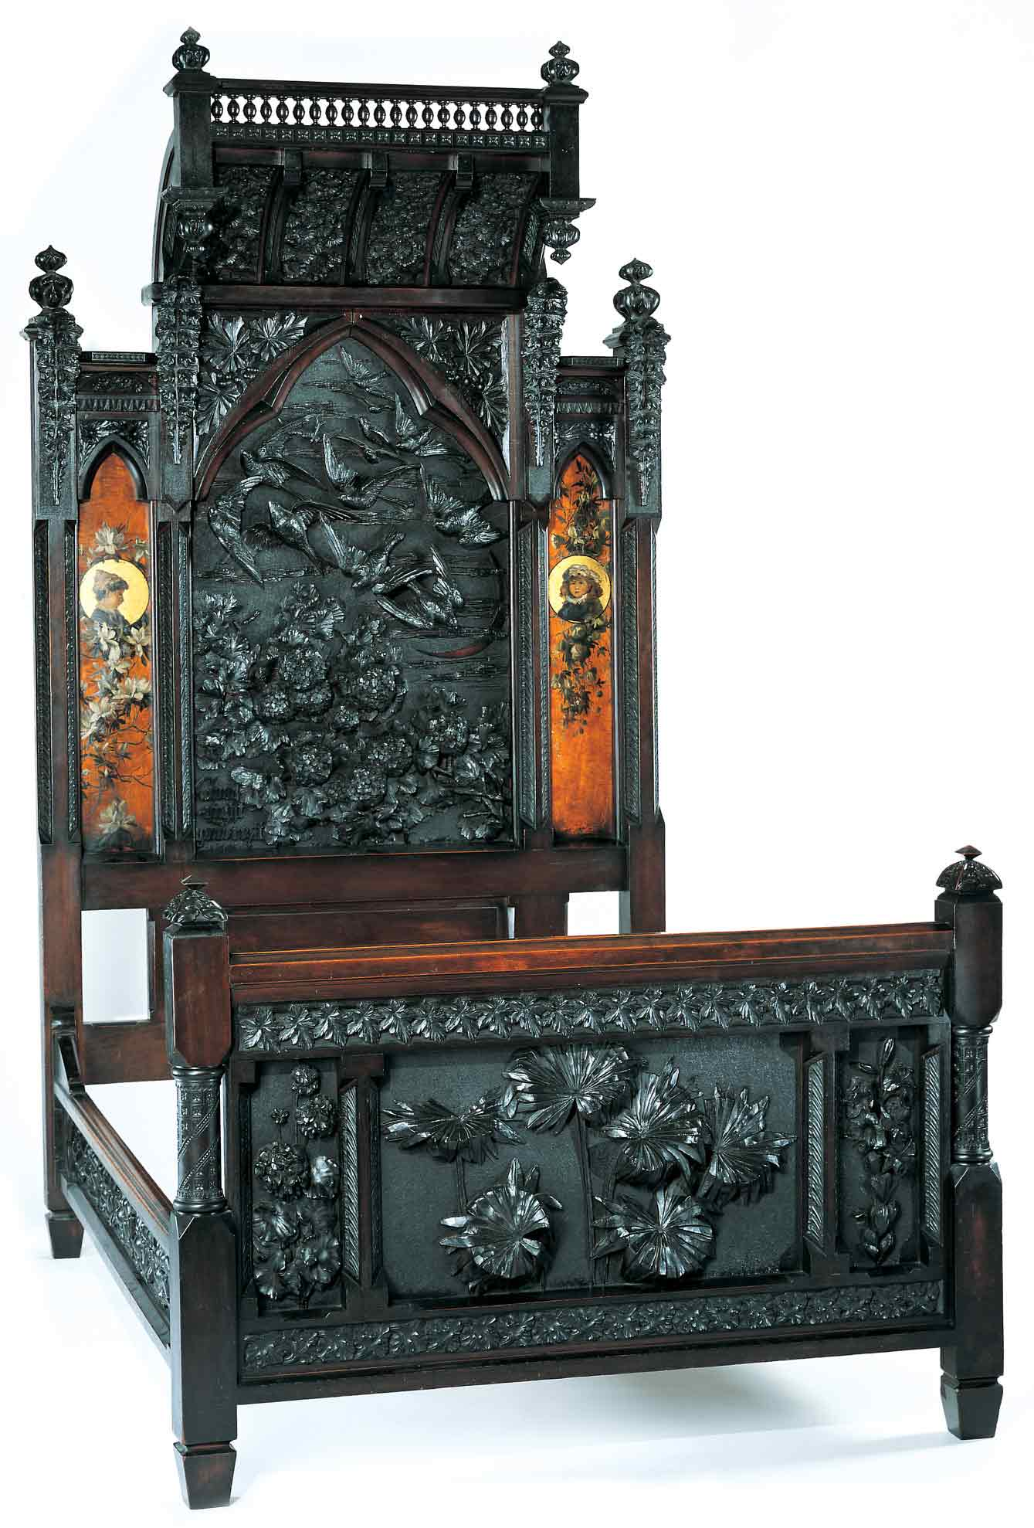
Benn Pitman (1822-1910), designer; Adelaide Nourse Pitman (1859-93), carver; and Elizabeth Nourse (1859-1938), painter
Bedstead, c. 1882-83
Gift of Mary Jane Hamilton in memory of her mother Mary Luella Hamilton, made possible through Rita S. Hudepohl, Guardian, 1994.61

Discovering the Story:
A City and Its Culture

What’s the Ratio?

A Math Lesson for Grades 4-8

Based on Bedstead
by Benn Pitman, Adelaide Nourse Pitman and Elizabeth Nourse

Concept TC "Concept" \f C \l "1"

Using dimensions of the Bedstead, students will determine the ratio between the dimensions of the reproduction of the Bedstead and the actual object. The teacher will facilitate students in study and hands-on application of ratio and scale through pre-videoconferencing lesson activities, a videoconference visit with the Cincinnati Art Museum, and post-videoconferencing lesson activities.

Objectives
Students will determine the dimensions of a life-sized element based on the dimensions of a smaller image through the use of scale.
Students will use the Bedstead to determine how perimeter and surface area change when the dimensions of an object are changed.
Students will appreciate the art and design of Benn Pitman and the Nourse sisters.

Teacher Preparation
Class Periods Required
1 to 2 (30-50 min.) periods for Pre- Videoconference Lesson Activities
1 (50-min.) class period for Videoconference
1 to 2 (30-50 min.) periods for Post- Videoconference Lesson Activities

Background Information
Background Information, on the Discovering the Story website at http://www.discoveringthestory.org/goldenage/bed/background.asp, contains additional details on the Bedstead and the artists who created it, has been written for teachers to review before the lesson and then share with students.

Video
Share the wood-carving video with your students prior to the videoconference. The video, on the website at http://www.discoveringthestory.org/goldenage/bed/video.asp, depicts wood carver Fred Wilbur as he carves in the style of works in the Museum. He speaks at length on the Bedstead. This video is an excellent resource that will help to prepare students for the videoconference. Video Duration – 5 minutes.

Pre- Videoconference Lesson Activities

Vocabulary

Definitions can be found in the Glossary on the Discovering the Story website at http://www.discoveringthestory.org/goldenage/bedstead/glossary.asp.
Arch
Column
Footboard
Headboard
Panel
Ratio
Scale
Sideboard
Spindle

Guiding Questions
- What shapes are incorporated into the Pitman headboard and footboard?
- How can we use measurements found on an image of the Bedstead to determine how large the actual bed is?
- How do scale drawings like blueprints help us build things?
- Why are accurate measurements essential in creating scale drawings or models?

Materials
Picture of the Bedstead from the Discovering the Story website at http://www.discoveringthestory.org/goldenage/images/bedstead_full.jpg
Scissors
Student copies of the Bedstead image

Procedure
Teacher will:
- Download image of the Bedstead from the Discovering the Story website. Make a copy for each student. Have a brief discussion about the Bedstead and its creators, Benn Pitman and the Nourse sisters.
- Have students, as a group, identify the shapes and construction components (i.e., footboard, headboard, sideboards) found on the image. Have students circle and label each shape. Discuss how shapes are an element of both art and math and how they give structure and decoration to everyday objects.
- Discuss that this downloaded image is a scale reproduction of the original, much larger, piece of furniture. Show pictures of other scale reproductions like blueprints. Discuss why accurate measurements on scale drawings are essential for building objects.
- Ask students how they could determine how large the bed really is if it is ten times larger than the image. Discuss possible solutions to the problem. Show students how taking the measurement of one dimension and multiplying it by ten will give you the actual size of that component of the bed.
- Identify one of the shapes or construction components. Have students cut out the shape/component. As a group, measure the dimensions of the shape and then determine what the dimensions would be if the real bed shape/component were ten times larger than the image. If the students do their measurements in inches, they should convert their final numbers to feet and inches.
- Using what they learned in the above problem, have students write out the equation for determining the size of a real object based on its scale reproduction, Using what they learned in the above problem.
- Carry out the Art Enrichment Activity. Students make models of the Bedstead.

Videoconference
Objectives
- Students will interact with the Cincinnati Art Museum staff through a sixty-minute videoconference. Information is at http://www.discoveringthestory.org/videoconference/.
- Students will learn about Cincinnati history from 1850 to 1900.
- Students will use Museum objects to reinforce activities completed in preparation for this videoconference.

Concept
A videoconference conducted by the Cincinnati Art Museum staff extends student learning through emphasis on the viewing and discussion of art objects. During this videoconference with the Museum, students will explore Cincinnati art history and the methods and practices of many of the artists working in the city.

Schedule
- 5 minutes Introduction to CAM staff (This is also buffer time in case of connection complications)

- 10 minutes Brief discussion of student pre-videoconferencing activities.

- 10 minutes Museum staff will lead an interactive discussion with students on the history of Cincinnati from 1850-1900

- 20 minutes Museum staff will lead students in an in-depth investigation of selected Museum objects.

Objects Include
- Bedstead by Benn Pitman, Adelaide Nourse Pitman, and Elizabeth Nourse. http://www.discoveringthestory.org/goldenage/images/bedstead_full.jpg
- Reception Dress by Selina Cadwallader. This image can be found at
http://www.discoveringthestory.org/goldenage/images/dress_full.jpg
- Aladdin Vase by Maria Longworth Nichols Storer, which is available at
http://www.discoveringthestory.org/goldenage/images/aladdin_full.jpg
  - Ali Baba Vase by M. Louise McLaughlin, which is available at
http://www.discoveringthestory.org/goldenage/images/alibaba_full.jpg
- Vase and Dedication Medallion by Tiffany & Co. This image is on the Website at
http://www.discoveringthestory.org/goldenage/images/springer_full.jpg

- 10 minutes Questions and student sharing of art projects.

- 5 minutes Closing (This is also buffer time in case of connection complications)

Post- Videoconference Lesson Activities
Materials
- Paper
- Pencils

Procedure
Teacher will:
- Using the formula for scale developed by the students in the pre-lesson, have students determine the actual ratio between the photo and the Bedstead. (The actual measurements of the Bedstead are 85 in. (219.5 cm.) by 59.25 in. (149.9 cm.)
- Using the same shape/component measured in the pre-lesson, have students determine the perimeter and surface area of the shape/component. Using their knowledge of ratio between the photo and the actual object, have students estimate the perimeter and surface area of the actual Bedstead.
- Next, have students use the actual measurements of the Bedstead to determine the perimeter and surface area of the life-sized shape/component.
- Compare their estimates to the actual numbers. Is the ratio different between the perimeter measurements and the surface area measurements? Discuss the difference.

Assessment Objectives
- Students can explain how ratio and scale drawings are used in everyday life/business.
- Students can explain why accurate measurements are important when creating a scale drawing.
- Students can use ratio to determine the size of actual objects based on scale drawings.
- Students can explain what happens to perimeter and surface area when the dimensions of an object are changed.

Academic Content Standards

National Standards: Mathematics
Grades 6-8
Standard 4: Understands and applies basic and advanced properties of the concepts of measurement.
Benchmark 6: Selects and uses appropriate units and tools, depending on degree of accuracy required, to find measurements for real-world problems.

Standard 5: Understands and applies basic and advanced properties of the concepts of geometry.
Benchmark 5: Understands the relationships between two- and three-dimensional representations of a figure (e.g., scale drawings, blueprints, planar cross sections).

National Standards: Visual Arts
Standard 4: Understands the visual arts in relation to history and cultures.

Grades 5-8
Benchmark 1: Understands similarities and differences among the characteristics of artworks from various eras and cultures.
Benchmark 2: Understands the historical and cultural contexts of a variety of art objects.
Benchmark 3: Understands how factors of time and place influence visual, spatial, or temporal characteristics that give meaning or function to a work of art

Ohio Standards: Mathematics
Grades 5-7
Measurement: Students estimate and measure to a required degree of accuracy and precision by selecting and using appropriate units, tools, and technologies.
Benchmark F: Applies and explains what happens to area and perimeter or surface area and volume when the dimensions of an object are changed.

Geometry and Spatial Sense: Students identify, classify, compare, and analyze characteristics, properties, and relationships of one-, two-, and three-dimensional geometric figures and objects. Students use spatial reasoning, properties of geometric objects, and transformations to analyze mathematical situations and solve problems.
Benchmark J: Applies properties of equality and proportionality to solve problems involving congruent or similar figures (e.g., create a scale drawing).

Ohio Standards: Visual Arts

Historical, Cultural, and Social Contexts: Students understand the impact of visual art on history, culture, and society from which it emanates. They understand the cultural, social, and political forces that, in turn, shape visual art communication and expression. Students identify the significant contributions of visual artists to cultural heritage. They analyze the historical, cultural, social, and political contexts that influence the function and role of visual art in people’s lives.

Grades 5-8

Benchmark A: Compares and contrasts the distinctive characteristics of art forms from various cultural, historical, and social contexts.

Benchmark D: Researches culturally or historically significant works of art and discusses their roles in society, history, culture, or politics.

Analyzing and Responding: Students identify and discriminate themes, media, subject matter, and formal technical and expressive aspects in works of art. They understand and use the vocabulary of art criticism to describe visual features, analyze relationships, and interpret meanings in works of art. Students make judgments about the quality of works of art using the appropriate criteria.
Grades 5-8
Benchmark A: Applies the strategies of art criticism to describe, analyze, and interpret selected works of art.

