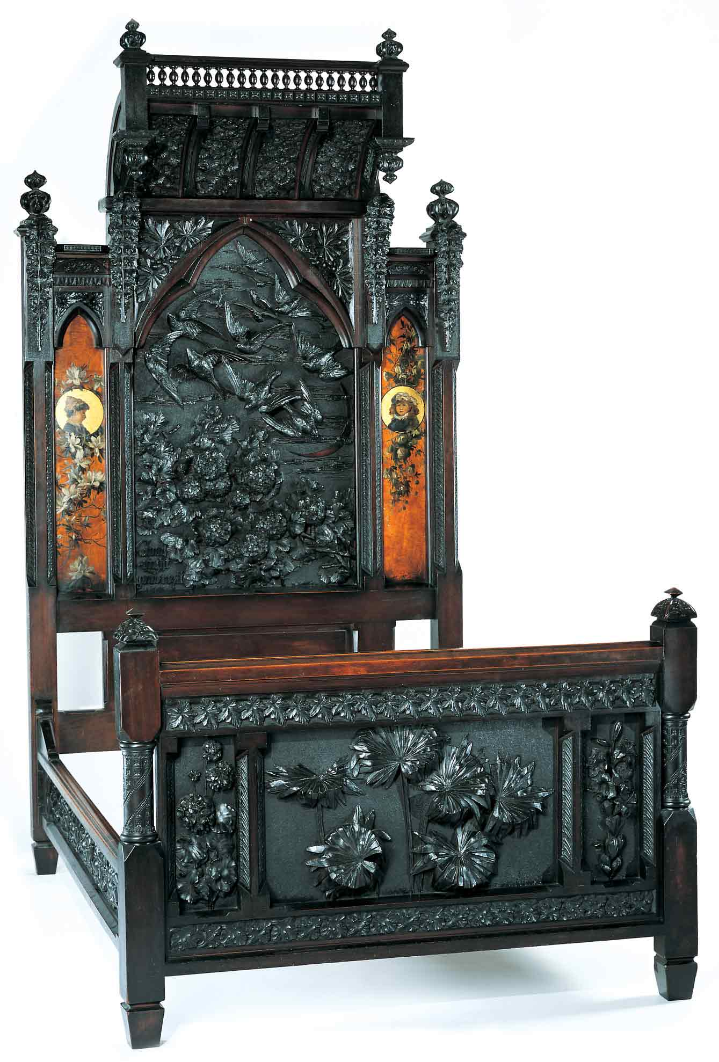
Discovering the Story:
A City and Its Culture

Extra! Extra! Read All About It!

A Language Arts Lesson for Grades 4-8

Based on Bedstead
by Benn Pitman, Adelaide Nourse Pitman and Elizabeth Nourse

Benn Pitman (1822-1910), designer; Adelaide Nourse Pitman (1859-93), carver; and Elizabeth Nourse (1859-1938), painter
Bedstead, c. 1882-83
Gift of Mary Jane Hamilton in memory of her mother Mary Luella Hamilton, made possible through Rita S. Hudepohl, Guardian, 1994.61

Concept

The object of focus, the Bedstead, designed and carved in the late 1880s, is representative of furniture making by Cincinnati women artists. The bed incorporates intricate carvings of flora and fauna, and day and night imagery. The printed guide to the object and the videoconference experience will lead to student recognition of the historical significance of the Pitman Bedstead. Students will do further research on the object and will write an informational newspaper article about the history and significance of the Bedstead.

Objectives
- Students will develop and learn to apply strategies that help them to comprehend and interpret informational texts.
- Students will locate, select, and make use of relevant information from a variety of media, reference, and technological sources.
- Students will engage in the writing process to create an original informational writing piece about the Bedstead.
- Students will appreciate the art and design of Benn Pitman and the Nourse sisters.

Teacher Preparation
Class Periods Required
1 to 2 (30-50 min.) periods for Pre-Lesson Activities
1 (50-min.) class period for Videoconference
1 to 2 (30-50 min.) periods for Art Enrichment Activity (optional)

Background Information
Background Information, which contains additional details on the Bedstead and the artists who created it, has been written for teachers to review before the lesson and then share with students. Background information can be found on the Discovering the Story website at http://www.discoveringthestory.org/goldenage/bed/background.asp.

Video
Share the wood-carving video with your students prior to the videoconference. The video, which is at http://www.discoveringthestory.org/goldenage/bed/video.asp, depicts wood carver Fred Wilbur as he carves in the style of works in the Museum. He speaks at length on the Bedstead. This video is an excellent resource that will help to prepare students for the videoconference. Video Duration – 5 minutes.

Pre- Videoconference Lesson Activities

Vocabulary

Definitions can be found in the Glossary on the Discovering the Story website at http://www.discoveringthestory.org/goldenage/bed/glossary.asp.

Description

Informational Documents
Media

Guiding Questions
- What are important aspects of a newspaper article?
- Why is the Bedstead important to Cincinnati history?

Materials
- Large lined chart paper
- Colored markers

Procedure
Teacher will:
- Provide the written background information on the Bedstead provided by the Museum. Have students read the information individually or in a large group depending on grade/ability level of students.
- Discuss in small or large group. Lead student discussion to address how images on the Bedstead impart information about Cincinnati in its late years of the 1800s (e.g., the native flora and fauna), and about the people who valued it.
- Instruct students to take notes from the written information.
- Compare/discuss/revise notes as needed.
- Show wood-carving video with students taking notes.
- Compare/discuss/revise notes as needed.
- Using the notes they have gathered, have students work individually or in groups to create questions for the videoconference.
- Participate in videoconference and have students take notes during the conference.

Videoconference
Objectives
- Students will interact with the Cincinnati Art Museum staff through a sixty-minute videoconference. Information is at http://www.discoveringthestory.org/videoconference/.
- Students will learn about Cincinnati history from 1850 to 1900.
- Students will use Museum objects to reinforce activities completed in preparation for this videoconference.

Concept
A videoconference conducted by the Cincinnati Art Museum staff extends student learning through emphasis on the viewing and discussion of art objects. During this videoconference with the Museum, students will explore Cincinnati art history and the methods and practices of many of the artists working in the city.

Schedule
- 5 minutes Introduction to CAM staff (This is also buffer time in case of connection complications)

- 10 minutes Brief discussion of student pre-videoconferencing activities.

- 10 minutes Museum staff will lead an interactive discussion with students on the history of Cincinnati from 1850-1900

- 20 minutes Museum staff will lead students in an in-depth investigation of selected Museum objects.

Objects Include
- Bedstead by Benn Pitman, Adelaide Nourse Pitman, and Elizabeth Nourse. http://www.discoveringthestory.org/goldenage/images/bedstead_full.jpg
- Reception Dress by Selina Cadwallader. This image can be found at
http://www.discoveringthestory.org/goldenage/images/dress_full.jpg
- Aladdin Vase by Maria Longworth Nichols Storer, which is available at
http://www.discoveringthestory.org/goldenage/images/aladdin_full.jpg
  - Ali Baba Vase by M. Louise McLaughlin, which is available at
http://www.discoveringthestory.org/goldenage/images/alibaba_full.jpg
- Vase and Dedication Medallion by Tiffany & Co. This image is on the Website at
http://www.discoveringthestory.org/goldenage/images/springer_full.jpg

- 10 minutes Questions and student sharing of art projects.

- 5 minutes Closing (This is also buffer time in case of connection complications)

Post- Videoconference

Procedure
Teacher will:
- Using notes from the background information, wood-carver video, videoconference, and other materials if desired, have students write an informational piece about the significance of the Bedstead. This could be in the style of a newspaper article or another format appropriate for students to demonstrate their findings.
- Have students use all stages of the writing process (prewriting, drafting, revising, and editing) prior to publishing their work.
- Have students illustrate their written work with all or part of the Bedstead.
- Carry out the art enrichment activity. Students will make models of the Bedstead.

Assessment Objectives
- Student gathered important facts for informational piece.
- Student based newspaper article on relevant and accurate facts.

Academic Content Standards

National Standards: Language Arts

Reading
Standard 7: Uses reading skills and strategies to understand and interpret a variety of informational texts.
Grades 6-8
Benchmark 1: Uses reading skills and strategies to understand a variety of informational texts.
Benchmark 2: Knows the defining characteristics of a variety of informational texts.
Benchmark 3: Summarizes and paraphrases information in texts (e.g., arranges information in chronological, logical, or sequential order; conveys main ideas, critical details, and underlying meaning; uses own words or quoted materials; preserves author's perspective and voice).
Benchmark 4: Uses new information to adjust and extend personal knowledge base.

Writing
Standard 1: Uses the general skills and strategies of the writing process.

Grades 6-8
Benchmark 1: Prewriting: Uses a variety of prewriting strategies.
Benchmark 2: Drafting and Revising: Uses a variety of strategies to draft and revise written work.
Benchmark 3: Editing and Publishing: Uses a variety of strategies to edit and publish written work.
Benchmark 4: Evaluates own and others' writing.
Benchmark 5: Uses content, style, and structure appropriate for specific audiences and purposes.

Standard 2: Uses the stylistic and rhetorical aspects of writing.

Grades 6-8
Benchmark 1: Uses descriptive language that clarifies and enhances ideas.
Benchmark 2: Uses paragraph form in writing.
Benchmark 3: Uses a variety of sentence structures to expand and embed ideas.

Standard 3: Uses grammatical and mechanical conventions in written compositions.
Grades 6-8
Benchmark 1: Uses conventions of print in writing.
Benchmark 2: Uses complete sentences in written compositions.
Benchmark 3: Uses declarative and interrogative sentences in written compositions.
Benchmark 4: Uses nouns in written compositions.
Benchmark 5: Uses verbs in written compositions.
Benchmark 7: Uses adverbs in written compositions.
Benchmark 8: Uses conventions of spelling in written compositions.
Benchmark 9: Uses conventions of capitalization in written compositions.
Benchmark 10: Uses conventions of punctuation in written compositions.

National Standards: Visual Arts

Standard 4: Understands the visual arts in relation to history and cultures.

Grades 5-8
Benchmark 1: Understands similarities and differences among the characteristics of artworks from various eras and cultures.
Benchmark 2: Understands the historical and cultural contexts of a variety of art objects.
Benchmark 3: Understands how factors of time and place influence visual, spatial, or temporal characteristics that give meaning or function to a work of art

Ohio Standards: Language Arts

Reading Process; Concepts of Print, Comprehension Strategies: Students develop and learn to apply strategies that help them to comprehend and interpret informational and literary texts. Reading and learning to read are problem-solving processes that require strategies for the reader to make sense of written language and remain engaged with texts. Beginners develop basic concepts about print (e.g., that print holds meaning) and how books work (e.g., text organization). As strategic readers, students learn to analyze and evaluate texts to demonstrate their understanding of text. Additionally, students learn to self-monitor their own comprehension by asking and answering questions about the text, self-correcting errors, and assessing their own understanding. They apply these strategies effectively to assign and self-select texts read in and out of the classroom.
Grades 4-7
Benchmark A: Determines a purpose for reading and use a range of reading comprehension strategies to better understand text.
Benchmark B: Applies effective reading comprehension strategies, including summarizing and making predictions, and comparisons using information in text, between text and across subject areas.

Reading Applications: Informational, Technical, and Persuasive Text: Students gain information from reading for purposes of learning about a subject, doing a job, making decisions, and accomplishing a task. Students need to apply the reading process to various types of informational texts, including essays, magazines, newspapers, textbooks, instruction manuals, consumer and workplace documents, reference materials, multimedia, and electronic resources. They learn to attend to text features, such as titles, subtitles, and visual aids; to make predictions; and build text knowledge. They learn to read diagrams, charts, graphs, maps, and displays in text as sources of additional information. Students use their knowledge of text structure to organize content information, analyze it, and draw inferences from it. Strategic readers learn to recognize arguments, bias, stereotyping, and propaganda in informational text sources.

Grades 4-7
Benchmark A: Uses text features and graphics to organize, analyze, and draw inferences from content and to gain additional information.
Benchmark E: Explains the treatment, scope, and organization of ideas from different texts to draw conclusions about a topic.
Benchmark F: Determines the extent to which a summary accurately reflects the main idea, critical details, and underlying meaning of original text.

Writing Process: Students’ writing develops when they regularly engage in the major phases of the writing process. The writing process includes the phases of prewriting, drafting, revising, and editing and publishing. They learn to plan their writing for different purposes and audiences. They learn to apply their writing skills in increasingly sophisticated ways to create and produce compositions that reflect effective word and grammatical choices. Students develop revision strategies to improve the content, organization, and language of their writing. Students also develop editing skills to improve writing conventions.
Grades 4-7
Benchmark A: Generates writing topics and establishes a purpose appropriate for the audience.
Benchmark B: Determines audience and purpose for self-selected and assigned writing tasks.
Benchmark C: Clarifies ideas for writing assignments by using graphics or other organizers.
Benchmark D: Uses revision strategies to improve the overall organization, the clarity and consistency of ideas within and among paragraphs, and the logic and effectiveness of word choices.
Benchmark F: Edits to improve fluency, grammar, and usage.
Benchmark H: Prepares writing for publication that is legible, follows an appropriate format, and uses techniques such as electronic resources and graphics.

Ohio Standards: Visual Arts

Historical, Cultural, and Social Contexts: Students understand the impact of visual art on history, culture, and society from which it emanates. They understand the cultural, social, and political forces that, in turn, shape visual art communication and expression. Students identify the significant contributions of visual artists to cultural heritage. They analyze the historical, cultural, social, and political contexts that influence the function and role of visual art in people’s lives.

Grades 5-8

Benchmark A: Compares and contrasts the distinctive characteristics of art forms from various cultural, historical, and social contexts.

Benchmark D: Researches culturally or historically significant works of art and discusses their roles in society, history, culture, or politics.

Analyzing and Responding: Students identify and discriminate themes, media, subject matter, and formal technical and expressive aspects in works of art. They understand and use the vocabulary of art criticism to describe visual features, analyze relationships, and interpret meanings in works of art. Students make judgments about the quality of works of art using the appropriate criteria.
Grades 5-8
Benchmark A: Applies the strategies of art criticism to describe, analyze, and interpret selected works of art.

